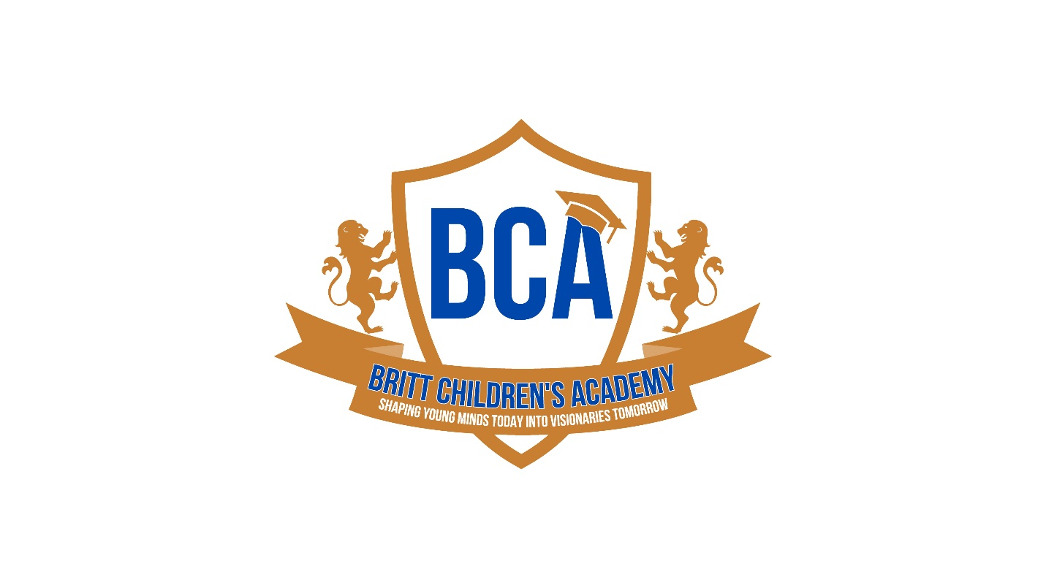
BRITT CHILDREN’S ACADEMY
PARENT HANDBOOK



Welcome to Britt Children’s Academy! We are so excited to welcome you into our BCA family! It is an honor for us to be able to have a small role in your child(ren) early education and we do not take this opportunity lightly.
We recognize the importance of a quality early childhood program and have made it our business to continuously exceed our benchmarks by hiring the best teachers, implementing innovative teaching methods with enriching activities that are aimed at developing the whole child.
Please read this handbook to acquaint yourself with our policies and procedures. Sign and return the back page indicating that you have read it in its entirety and agree to the following policies.
Thank you for choosing our school! We look forward to partnering with your family to ensure the best results for your child.
“Free the child’s potential and you will transform him into the world”
~Maria Montessori

TUITION POLICY
- All tuition payments are due on Monday morning of each week.
- A late payment fee of $20 per child will be added to your account if payment is not received on time.
- Auto-pay – Every family MUST sign up for autopay via the Brightwheel app where payment will be automatically deducted from your account EVERY Monday OR Tuition must be paid 2 weeks in advance thereby eliminating any balances.
- Attendance will be suspended after 2 weeks of no payment until all fees are paid in full.
- Non – payment after 2 weeks will result in withdrawal of enrollment.
- Parents who get paid on a bi-weekly schedule MUST pay ahead 2 two weeks to avoid carrying a balance.
- Any bounced checks will incur a fee of $35 (and that form of payment will no longer be accepted).
- If a payment made via the BrightWheel app is returned due to insufficient funds a $35 fee will be charged for each occurrence per child.
- Accepted forms of payment are debit/credit card via Bright Wheel app. Checks will be accepted at the center. Cash accepted but not preferred.
- A $75 annual registration fee is applied to every account July 1st yearly. For families with multiple children an additional $50 will be added.
- 1st week tuition and annual registration fee are due on or before first day of attendance.
- ALL FEES AND TUITION ARE SUBJECT TO CHANGE WITHOUT PRIOR NOTICE.
VACATION
- Every family is allotted a full week (5 consecutive days) for vacation which can be used within the current calendar year (Jan. – Dec.)
- You are not required to pay for this week.
- You can use your week for whatever reason (e.g. Illness, vacation, staycation etc.)
- Notify the center director and a note will be made in your file at least 2 weeks in advance.
ABSENCES
- We understand that absences are sometimes necessary. However, you are still required to pay even if your child is not present. This is industry standard and there will be no EXCEPTIONS.
- If a child is ill for longer than 2 weeks, they will be withdrawn from the program to avoid any additional charges.
- Weeks are not pro-rated for holiday days, pandemic or natural disasters which includes hurricanes, tornadoes etc.
- BCA or the parent may terminate enrollment at any time. A one week written notice must be provided by the parent to the center.
ELC PARENTS
- Parent co-payments are due every Monday.
- If your child is absent due to illness, they must return with a doctor’s note excusing their absence. Or, a note written and signed by you, the parent explaining their absence.
- In addition to parent copays, each parent is also responsible for paying the difference between what ELC pays for your child vs our actual rate (see example below).
** Ex: Parent has a 2yr old enrolled and participates in ELC. Weekly co-payment is $5. ELC pays $130 wkly. Learning Street’s actual rate, $150 wkly. The difference will be $20. Parent will pay $25 wkly. **

Reference the chart below for the amount that applies to your family:
AGE | BCA Tuition WKLY | ELC WEEKLY | WEEKLY DIFFERENCE
Infant | 200 | 200 | 0
1yr old | 160 | 153 | 7
2yr old | 150 | 130 | 20
3yr old | 135 | 120 | 15
4 yr old | 125 | 105 | 20
5yr old | 125 | 105 | 20

Please sign below acknowledging that you have read the above policy.

Parent/ Legal Guardian Name (print): ____________________________________

Parent/ Legal Guardian Signature: _______________________________________
Date: ____________________
PICK UP/DROP OFF
We require all children to be dropped off by 8:30 AM and no later than 9:00 AM. If the child(ren) has an appointment, please notify the director. Unless prior arrangements have been made, children will not be admitted after 9AM. We stop serving breakfast at 8:00 AM. If the children arrive after that, please make sure they have been fed.
Our hours of operation are 6:30a – 6:00p; you are late at 6:01p and the late fee is $50 per child with an additional $15 for every 15 minutes thereafter. This MUST be paid in CASH the morning of return to school. NO EXCEPTIONS
All parents are required to sign their child(ren) in and out using the BrightWheel app. A unique code will be assigned to each parent and approved pick up. Children are not allowed to sign themselves in/out. Only authorized persons are allowed to pick up children from the center. If you want to add a name, please notify the school’s director (in person) so they can be added to your profile and receive a code. It is the responsibility of the parent to ensure that anyone who is picking up or dropping off has the app and is singed up. We will require proper identification before the child is released.
BrightWheel:
If you are experiencing phone issues, a tablet is provided for your convenience.

ANYONE picking up your child must be on your list of approved pick up and must use the app! The process is simple to add someone.
-Send the information to Mrs. Deidre
-Make sure the person downloads the app
-That is it!
This information is vital in cases of emergencies, legal action etc.

Parent Notification:
All communications including but not limited to notifications, policy changes, upcoming events etc. will be done through the BrightWheel app. It is the responsibility of the parent to check the app to ensure they are current with what is happening at the school.

SUSPENSION
BCA reserves the right to suspend any student for behavior that goes against the center’s code of conduct or that maybe deemed unsafe to the well-being of other children and our staff. To protect all our children, our biting policy is as follows:
1st Offense – Parent Notification
2nd Offense – 2-day suspension
3rd Offense – Expulsion

***Any after schooler suspended from elementary school will not be allowed to attend our center during regular school hours as we must abide by the teacher/child ratio set forth in the Florida Statutes.***

MEDICATION POLICY
All medication must be submitted to the director or current supervisor. A parent/guardian must fill out an Authorization for Medication form giving the staff permission to administer the medication. We will only administer medication prescribed by a doctor. NO OVER THE COUNTER MEDICATION. All medication must be in its original container, labeled with the child’s full name, name of drug, dosage, directions for administration, date and physician’s name. It is the responsibility of the parent/guardian to communicate with the staff any medication given at home prior to dropping the child off. This information is important in the event of a reaction or emergency occurring at the center.

DRESS CODE
Daily at BCA, your child will experience a variety of activities. Appropriate clothing must be appropriate and unrestrictive so your child can comfortably participate in all activities. Clothing should be weather appropriate. All students are required to have a complete change of clothing including socks and underwear. Rompers, overalls, open-toed sandals and CROCS, MUST NOT be worn. All children must wear closed toed shoes that are secured to their feet. It is the parent’s responsibility to label all items of clothing and bedding. Britt Children’s Academy will not be responsible for any damaged or lost items. Jewelry, except for earrings are prohibited.

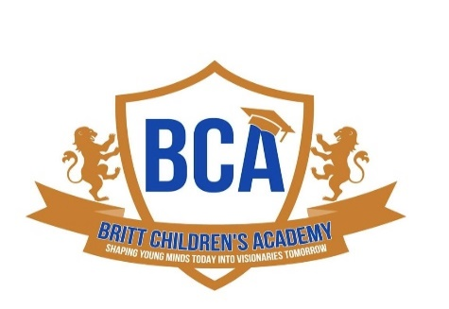
Sickness Policy
Britt Children’s Academy strives for healthy minds as well as healthy bodies. Your child's health is a matter of major importance to us. If your child becomes ill during the day, they will be excluded from all activities and you will be notified to pick them up. For the comfort of your child(ren) and to reduce the risk of contagion, we ask that your child is picked up within an hour and a half of notification.
Children must remain home 24 hours from the time of being sent home. This time includes the remainder of the day they were sent home and the entire day after. They must return with a doctor’s note.
***Please not that if your child is still exhibiting symptoms of a contagious illness, they will not be allowed to return to school, even with a doctor’s note, until symptoms have lessened or have disappeared. ***
The following is a list of common illnesses but not limited to the following:
• Nausea or vomiting /Fever • Loss of voice
• Bloody stool • Sore throat with fever
• Unusually dark urine and/or gray or white stool
• Difficult or rapid breathing • Body rash with fever
• Stiff neck • Yellow skin or eyes
• Swollen glands • Exposed, open skin lesions
• Runny nose (other than clear) • Lice
• Eye or ear discharge • Any other unusual sign or symptom of illness
• Diarrhea (more than one abnormally loose stool within a 24-hour period)
• Hacking or continuous severe coughing which causes child to become red or blue in the face or make a whooping sound

BCA reserves the right to determine whether or not a child must go home due to illness.

Parent/Guardian Signature: _______________________

Parent/Guardian Name (printed): ________________________________
Date: __________________________

