Welcome to Kids Connect Childcare Center
We are happy your family has chosen our school
We are open Monday-Friday 6:30am-6:30pm
- Breakfast 7am-8am
- Lunch 11:00am-12pm
- Snack 2pm-3pm
- Dinner 4:30-5:30pm

Here at Kids Connect Child Care Center we require each child 2 years of age and older to wear uniforms. Please read additional paper work to see what our uniform attire is.

Here is a checklist to help you and your child be prepared for their first day of school!
- $50 registration fee due at the time of you registering your child
- Enrollment application
- Up to date Immunization form & Physical
- Food program application
- Emergency contact form
- Influenza virus brochure and Distracted driver form

General Information 6 weeks-24 Months
- 2 change of clothes
- 1 crib sheet and blanket for nap
- At least 6 diapers a day with your child’s name written on each one (you are welcome to bring in a Pack) with a pack of wipes
- 2 bottles with your child’s first and last name written on them (infants only)
- 1 gallon of baby water with one can of your child’s baby formula (if your child eats baby food, please send at least 3 jars a day)
- 1 full size back pack (1 year olds only)

(24 months and Up)
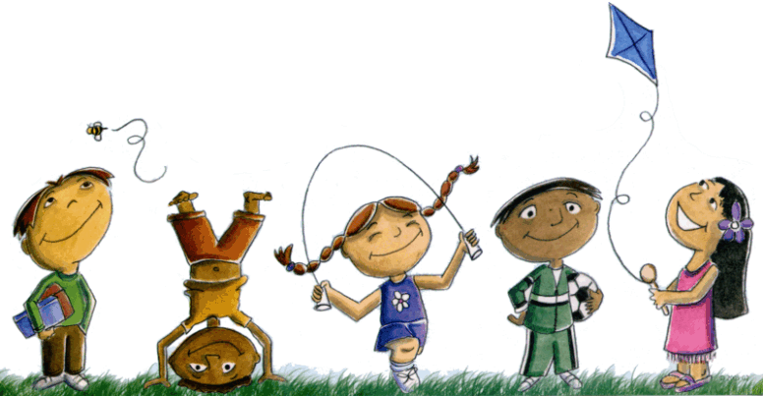
- 1 change of clothes
- 1 crib sheet and blanket for nap
- One full size back packs (no mini size back packs)

