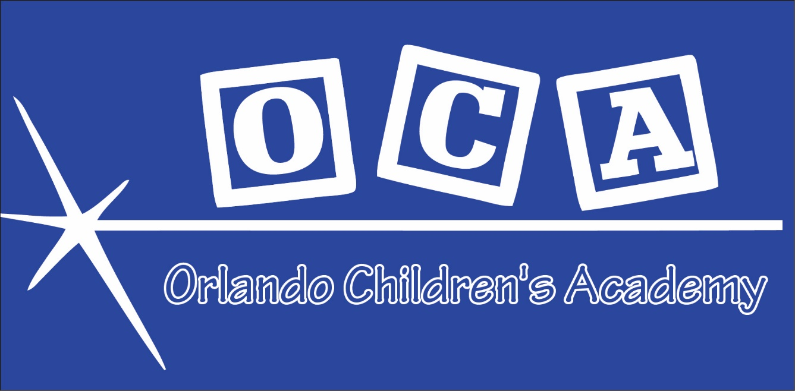

Where love and creativity are inspired to Grow

1555 Americana Boulevard
Orlando, FL 32839
Main: 407-859-2055
Fax: 407-393-5505
Orlando Children’s Academy
PArent Handbook

Statement of Commitment*

As an individual who works with young children, I commit myself to furthering the values of early childhood education as they are reflected in the ideals and principles of Orlando Children’s Academy and the NAEYC Code of Ethical Conduct. To the best of my ability I will:

• Never harm children.
• Ensure that programs for young children are based on current knowledge and research of child development and early childhood education.
• Respect and support families in their task of nurturing children.
• Respect colleagues in early childhood care and education and support them in maintaining the Orlando Children’s Academy Handbook and NAEYC Code of Ethical Conduct.
• Serve as an advocate for children, their families, and their teachers in community and society.
• Stay informed of and maintains high standards of moral and professional conduct.
• Engage in an ongoing process of self-reflection, realizing that personal characteristics, biases, and beliefs have an impact on children and families.
• Be open to new ideas and be willing to learn from the suggestions of others.
• Continue to learn, grow, and contribute as a professional.
• Honor the ideals and principles of Orlando Children’s Academy and the NAEYC Code of Ethical Conduct.

Dear Parent,

We would like to take this opportunity to welcome you to Orlando Children’s Academy. This Parent/Student Handbook will provide a great deal of information about our policies and procedures. We would encourage you to take a moment to read the handbook and ask any questions you may have.

The staff at Orlando Children’s Academy is committed to providing a loving, caring, nurturing environment for the children in our care. We know you are entrusting your most precious loved ones to us, and we do not take this responsibility lightly and will strive for excellence in the care of your child. At Orlando Children’s Academy, our mission is to provide a safe, nurturing, and progressive environment for the development of future leaders.

Joy Bouler
Executive Director

Table of Contents
Table of Contents
Organization 5
Management 5
Mission Statement 5
Non-Discrimination Policy 6
WHO WILL BE CARING FOR YOUR CHILD?......................................................................6
Statement of Faith: 7
ENROLLMENT AND FEE POLICIES 8
Admission/Enrollment Policy 8
Enrollment Procedures 8
Health Requirements 8
Registration 9
Annual Administration Fee 9
Tuition Schedule 9
Vacation 10
Sick Days 10
Withdrawals 10
Late Pick Up 11
Holidays & Teacher Development Days 11
PROGRAM INFORMATION 12
Programs 12
Voluntary Preschool Program (VPK) 13
Curriculum 13
Progress Folders 14
Preschool Program 14
IEP or ILP 14
Special Needs 14
Clothing and Personal Belongings 14
Weekly Necessities List 15
Meals/Snack Time 15
Nap/Rest Time 15
Birthdays/Holidays/Special Occasions 15
Transportation 16
Television and Video Viewing 16
Movie Policy 16
Outdoor Play 16
Show and Tell 17
Transitions 17
Transition to Kindergarten 17
PARENT/GUARDIAN/STAFF COMMUNICATIONS 18
Supporting Your Child 18
Child Observation and Incident Reports 18
Parental Involvement and Volunteers 19
Visiting with Siblings 19
Staffing Changes 19
Conferences 19
Messages 19
Questions, Concern, and Conflict: 19
Documentation of Children’s Activities: 19
Parental Consent for Photography 20
Program Evaluation 20
Staff Parent Fraternization 20
Child Abuse and Neglect 20
Access/Availability 21
Parent Availability 21
Arrival/Pick Up Procedures 21
Arriving Late for the Day 21
Early Pick Up Procedure 21
Emergency Evacuation and Relocation Plan 21
HEALTH AND SAFETY PRACTICES 23
Medication 23
Emergency Procedures and Notification 23
Inclement Weather/Disaster 24
Sick Child Policy 24
Infection Control 24
Smoking Policy 24
Emergency Drills and Procedures 25
Accident/Incident/Injury Reporting 25
CPR and First Aid 25
Discipline Policy 26

Organization

Orlando Children’s Academy is owned and operated by Orlando Children’s Academy LLC, a Florida Limited Liability Company

Orlando Children’s Academy is governed by the Regulatory Statutes for Licensed Child Care Centers for the State of Florida. It has met all the qualifications and requirements set by the State of Florida and has a management team that handles the operations of this program. Our facility is dedicated to the care and concern of all children of the community, including those of limited economic means.

Management

Joy Bouler – Executive Director/ Managing Member
Harold Bouler- Member

Center has contact information posted throughout facility. It is regularly updated when changes are necessary. Please view these postings at any time.

The Director is responsible for the day to day operations of this program. If you have any questions, concerns and input for the development of the program and the children, the Director is available to you.

Mission Statement
The Orlando Children’s Academy mission is to provide a safe, loving, comfortable, literacy rich environment where children are inspired to be creative and grow into strong well-rounded individuals

Philosophy
Our philosophy at Orlando Children’s Academy is that children deserve the highest quality childcare and biblically based education in a safe, nurturing learning environment. The philosophy of management and staff, the care of the children, and the curriculum are biblically based. Using Christian ideals and principles we will develop a learning structure that fits the needs of each individual child. Children will be prepared for a school environment while still being allowed to develop at their own pace. This will help to promote a positive self-esteem in each child. Our policies and procedures for our staff and center will be based on these same Christian ideals and principles. Staff members will be encouraged to continually educate themselves and be innovative in the classrooms. They will be challenged to develop and nurture each child to learn and be creative. Our commitment is to the children and staff of Orlando Children’s Academy. This means not only providing the highest degree of care and concern possible for the children in our care, but also demonstrating that same level of care and concern for all employees.

Non-Discrimination Policy
All children are welcome at Orlando Children’s Academy. Children are admitted regardless of race, creed, sex, national origin, and/or religion.

WHO WILL BE CARING FOR YOUR CHILD?

Teachers

The administration of Orlando Children’s Academy seeks to hire and retain staff members who not only enjoy children, but who also have experience and education in working with them. New staff members are required to provide information for a criminal background check and a check with the Central Registry of Child Protection Services. Orlando Children’s Academy teachers are encouraged to attain Early Childhood Professional Credentials and the center supports continued training and college credits to meet ever-increasing teacher qualifications.

Volunteers
Our center will periodically use volunteers who wish to give time to our children. These volunteers will be supervised and given background checks as directed by Florida licensing regulations. They will also receive the same orientation to the program as regular staff members.

Parents
Parents are encouraged to assist in their child’s classroom when they have time. Please be aware that in doing so, you will be expected to interact with children in a friendly and appropriate manner and allow the classroom teachers to take care of behavior issues.

Staff Training, Education and Retention

Orlando Children’s Academy strives to provide a positive work environment that encourages people to remain with our program. We are aware that staff turnover is a major concern in child care, and we do whatever possible to minimize change for your child.

Training and time together allows OCA to build a sense of community among the staff members and work toward enhancing their skills with children. According to the research, ongoing training for teachers is one of the most critical factors in providing a quality early childhood program. All staff members must have a background screen prior to employment. First aid and CPR certification is also required. A state mandated forty-five hours of child development classes are required, a Child Development Associate (CDA) or equivalent are also part of the recommended training. Staff members will attend at least twelve hours of related in-service training per year.

Statement of Faith:
We believe the Bible to be the inspired and only infallible written Word of God.
We believe that there is only One God, eternally existent in three persons: God the Father, God the Son and, God the Holy Spirit.
We believe in the blessed Hope, which is the rapture of the Church of God, which is in Christ, at His return.
We believe that the only means of being cleansed from sin is through repentance and faith in the precious Blood of Jesus Christ.
We believe that regeneration by the Holy Ghost is absolutely essential for personal salvation.
We believe that the redemptive work of Christ on the Cross provides healing for the human body in answer to believing prayer.
We believe that the Baptism of the Holy Spirit, according to Acts 2:4, is given to believers who ask for Him.
We believe in the sanctifying power of the Holy Spirit, by whose indwelling the Christian is enabled to live a holy and separated life in the present world.

ENROLLMENT AND FEE POLICIES

Admission/Enrollment Policy
All students are required to have an active enrollment form on file.

Enrollment Procedures
Children will be enrolled and assigned to a classroom based on his/her age and developmental level. The following steps will be included in the enrollment process:
- Initial contact via phone or on-site visit
- Tour of facility
- Determination of space available for child/ren
- Enrollment (The following must also be turned in at enrollment):
  - Registration Fee
  - Enrollment Application
  - Income Eligibility Form (CACFP)
  - CACFP Annual Child Enrollment Form
  - Record of immunizations – if immunizations are not up-to-date, the series must have been started, and the anticipated completion date provided.
  - Signature page of “Know Your Child Care Center” Brochure
- If possible, gradual orientation to program through short, parent-accompanied visits and/or a home visit.

All enrollment paperwork will be placed in the child’s file and kept confidential in the Director’s office.

Health Requirements
Prior to enrollment all children will need all required medical information and consent forms. A current physical examination (HRS-H Form 3040) and current immunization record (DH Form 680 or 681) is required within five (5) days of enrollment. Failure to provide the appropriate forms will result in suspension or termination of enrollment without a refund.
ORLANDO CHILDREN’S ACADEMY
(as of January 1, 2015)

Weekly Tuition Rates and Fees
Infants (4 wks-18 months) $140.00

Toddlers (18 months- 36 months) $125.00

Preschool (3 yrs up to 5 yrs) $110.00

School age (5yrs and up) $85.00

School-age Before School (only) $ 50.00

School-age After School (only) $ 50.00

PRIVATE PAY RATES CAN BE CONTRACTED WITH DIRECTOR FOR FULL AND PART TIME CARE

Registration Fee $50.00
Summer Activity Fee $75.00
Annual Administration Fee Varies

Registration
A one time, non-refundable registration fee will be charged prior to enrollment at Orlando Children’s Academy to hold a classroom spot for your child. If a child is withdrawn and re-enrolled at a later date, a re-enrollment fee of $50 per child will be assessed. Failure to comply with Vacation and/or Sick Day policies will also result in a re-enrollment fee.

Annual Administration Fee
An annual Administration fee is required for each child, this fee is non-refundable. It is due August 1st of each year regardless of enrollment date. This fee is per child and all tuition/fees rules apply.

Tuition Schedule
All tuitions are due the Friday of the previous week. Any tuition not paid by Friday will assessed a $25 late fee. If tuition is not paid by 12 Noon the Monday of the current week, a temporary suspension will be placed and children will not be allowed to attend until tuition is paid in full, including any accumulated fees. If tuition is not paid by the following Friday the child will lose his/her spot and will need to re-enroll and will be required to pay our re-enrollment fee.

Tuition paid is for the schedule agreed upon in advance between parents and
Orlando Children’s Academy. This reserves the child’s place in their class. If a child does not attend all scheduled days, there will not be a refund. Tuition is due whether the child attends or not, unless agreed upon in advance. If a child is part time and attends additional days, they will be assessed the drop in rate. The fees for drop ins will be paid upon dropping off the child.

Tuition is based on child’s age/date of birth and not necessarily the group/class placed.

Orlando Children’s Academy will NOT accept cash payments. We will accept checks, credit cards, money order or official check. If payment is to be made by check, a valid credit card must be kept on file. We reserve the right to charge any returned check, balance, fees or other accumulated expenses to this credit card immediately and in full or partial as needed.

Returned Checks are subject to a minimum of $35 returned check fees and any other fees due such as late fees or bank fees. Any returned check will result in all future payments to be made by money order, credit card or official check.

A multi-child discount of 10% for additional children after first full tuition for youngest child is available. Discounts are only available to full-time children.

The tuition schedule is subject to change with thirty days written notice to parents.

Vacation
After one year of uninterrupted enrollment each child will be eligible for one-week vacation per year for a $50 vacation fee for preschool and summer camp and $20 for before/after school care. A two-week notice must be given and fees paid to hold your child’s spot at KIDSCONNECT. Prior to one-year enrollment full week tuition must be paid for any vacation time.

Sick Days
Sick days will be paid at the same rate as regular attendance days due to staffing and licensing requirements for such. No prorating for sick days will be done.

Withdrawals
Parents may choose to withdraw a child from Orlando Children’s Academy at any time with two weeks written notice. If a two-week notice is not given, you will be responsible for tuition for that time period. Withdrawal and re-enrollment will require a new enrollment packet and $50 (per child) re-enrollment fee.

Discharge Policy
The Orlando Children’s Academy’s director reserves the right to cancel the enrollment of a child for:
- Non-payment of fee or parent co-payment if on 4C
- Excessive late pick-ups (“Excessive” will be based upon frequency and degree of lateness – a determination will be made by the director)
- A child with special needs that cannot be met within our current staffing patterns
- Chronic verbal or physical abuse of staff or children by either a child or a parent/guardian.
- Failure of parent to follow center policies

Reserving Your Slot
If for some reason you need to have your child out of the program for an extended period of time (more than two weeks), you can request that we hold the slot for you and pay ½ the regular weekly tuition for us to do so. Our demand for spaces will not allow us to hold the slot without this fee being paid.

Authorization
If your child care is being paid for by 4C or other funding source, we must receive written authorization before the child(ren) can start attending.

Late Pick Up
Orlando Children’s Academy closes promptly at 6:30pm. All children must be picked up prior to closing. If an emergency occurs please call the center at the earliest possible time. A late fee of $25 will be assessed for each child picked up after 6:30pm and an additional $25 per 15 minutes (billed in 15 minute increments) due immediately.

Holidays & Teacher Development Days
The following holidays will be observed and Orlando Children’s Academy will be closed. New Year’s Day, Martin Luther King Day, President’s Day, Good Friday, Memorial Day, 4th of July, Labor Day, Veteran’s Day, Thanksgiving & Day After, Christmas Eve/Christmas Day.

The center will also have two (2) scheduled teacher development days each calendar year.

You will still be responsible for paying full tuition during the weeks in which these holidays and vacation days fall.
.

PROGRAM INFORMATION

Programs
Orlando Children’s Academy enrolls children from the age of four weeks through kindergarten. School-aged children from kindergarten to fifth grade are enrolled in our Before/After program and offered enrollment into our Summer Camp program during summer break.

Each group will be offered age appropriate lesson plans and activities that will promote the following:
-Emotional, social, creative, intellectual and physical growth
-Individual and group active play indoors and outdoors
-Include meals, snacks and nap or rest times.

Monthly calendars will be made available to parents and posted in the classroom.

Infants
Infants are enrolled from four weeks to twelve months. They are cared for in our Infant Room. Staff will provide all routine, necessary infant care including diapering, cleaning and feeding. All infant diapers will be changed at a minimum of two-hour intervals or more as necessary. Infants are given safe, age appropriate toys and plenty of exercise time for crawling/walking in a sanitary and safe environment. Infants are provided with the necessary rest time in their own crib.

Toddlers 1’s
Toddlers are enrolled from twelve to twenty-four months. They are cared for in our Toddler Room. Staff will provide all routine, necessary care including diapering, cleaning and feeding. All toddler diapers will be changed at a minimum of two-hour intervals or more as necessary. Toddlers are provided age appropriate toys and activities to stimulate gross motor skills, socialization, and creative expression. They will also have the opportunity for outside play in their own playground area. Meals/snacks are provided for our toddlers in the toddler rooms.

Toddlers 2/3’s
Children ages twenty-four to thirty-six months are enrolled in our Toddler 2/3’s program. Staff will provide all routine, necessary care including diapering, cleaning and help feeding. Diapers (if appropriate) are changed at a minimum of two-hour intervals or more as necessary. Our Toddlers are divided into a “younger” and “older” group based on diaper/toileting needs. All Toddlers are cared for in an age appropriate, safe environment that allows for creative play, self-expression, self-help skills, and encouraged to develop their interests at a variety of learning centers. The Toddlers will have ample outside playtime on age appropriate play equipment in their own playground area. Meals/snacks are provided for our Toddlers in their rooms.

Pre-K 3/4
All Pre-K students are given the opportunity for more standard education and language, creative development. Our Pre-K’s have their own centers for learning and activities. Pre-K’s also graduate to our larger playground for ample outside play time. At this age they will still have naptime and meals and snacks are provided in their rooms.

Schoolers
Children ages five to twelve are enrolled in our Schoolers program. Children in this group are divided into two or three groups based on age and number of children enrolled. During the school year these children have the opportunity for before and after school care with transportation to and from local elementary schools. Snacks and outside playtime are provided for our Schoolers. Full day opportunities with appropriate activities are offered to our Schoolers during holidays and school days off.

Summer Camp
Children ages five to twelve can be enrolled in our Summer Camp program. Summer Camp is divided into two or more groups based on age and number of children enrolled. Our Campers have daily opportunities for indoor and outdoor play, arts and crafts, special programs (such as Little Chefs and Little Scientist, etc) as well as field trips. During the summer our focus is on activity and free play rather than education, but each day includes general educational instruction. Children may also take part in available lessons (at an additional cost) such as swimming, karate, dance, tumbling, etc. These programs are based on minimum groups of interested parents/children. During our Summer Camp program children are provided snacks and meals in our “cafeteria” setting.

Drop In Day Care
Drop In Care is available to parents that are currently enrolled in center but have reduced or changed hours due financial or scheduling changes. This program is based solely on daily availability. Any child who is part of our Drop In Day Care program will be placed in the appropriate age group. Parents must bring daily supplies and necessities for each child. All enrollment and medical forms must be filled out and available before any child can be part of the Drop In Day Care program.

Staff-To-Child Ratios
The following ratios are state mandated and OCA will meet and/or exceed all staffing requirements.

Infants 1:4
1 year olds 1:6
2 year olds 1:11
3 year olds 1:13
4 year olds 1:15
5 years + 1:25

Voluntary Preschool Program (VPK)

Curriculum
Orlando Children’s Academy will use a Bible based, state-approved educational curriculum that will fit the needs of each age group. Our curriculum will include daily/weekly Bible study, stories and prayer. We will also encourage creative play, language skills and cognitive learning as part of our daily curriculum.

Progress Folders
Each classroom will have a place for individual progress folders. Each child will have his or her own folder. Messages, Calendars, Notices, Telegrams, etc will be placed in these folders daily. Please make sure you check your child’s folder daily.

Preschool Program
We expect all children in this age group to arrive at the center by 8:30 or earlier. This not only assures that they will receive the maximum benefit from the program, but it also prevents disruption of the program when children come in during the middle of activities.
For the toddlers’ program, we request that your child arrive at least by 9:00 a.m. Coming in later than this can be disruptive to the regular routine of the class. If you must come in later due to an appointment, please let the staff in your child’s classroom know in advance.

IEP or ILP
Please inform the director if your child has an IEP (Individual Education Plan) or ILP (Individual Learning Plan) as the result of having been evaluated by the public school system. We will be glad to work with you and school personnel in helping to implement this plan. We also ask that you provide a copy of the document for your child’s file.

Special Needs
In accordance with the Americans with Disabilities Act, OCA will make every effort to work with children having special needs in our child care setting. We will ultimately base decisions on working with these children on whether we can adequately care for them as well as the other children with current staffing patterns. When there is a question about whether we will be able to meet the child’s needs, we will provide a two-week trial period during which time we will explore what might be necessary to make the situation workable for all. If we find that we cannot meet the needs of the child as well as those of the other children within our current staffing patterns, we will give the family two additional weeks, if needed, to find alternative care.

Clothing and Personal Belongings
We recommend children be dressed in comfortable clothing appropriate for the weather. For the safety of the children closed toes shoes must be worn, flip-flops or sandals cannot be worn.

Each child will have his or her own cubby that is personally labeled. So that children learn responsibility we recommend that each child be responsible for putting his or her own items in the cubby daily. Each child should have an extra set of clothing to be kept at the center at all times. If wet or soiled clothes are sent home please return another clean set the following day.

All personal belongings and clothes must be marked with each child’s name. Orlando Children’s Academy will not be responsible for any unmarked items.

Weekly Necessities List
Each teacher will develop a weekly list of supplies and necessities based on age appropriateness. It is the responsibility of each parent to make sure these items are brought in weekly. If items are needed and are not supplied by the parent, a charge may be added for those items.

Any clothing, bedding, etc. should be taken home on Friday’s to be washed and returned the following Monday.

Meals/Snack Time
OCA will provide nutritional, well-balanced meals and snacks for each child depending on which part of the day is spent at our center. Breakfast will be provided for those arriving before the end of the designated Breakfast period. A healthy lunch, and an afternoon snack will be provided as well. Water is available at all times during the day for the children.

Please make sure our staff is aware of any allergies or special diet needs in writing. Please make sure any corrections or additions are made immediately to ensure a safe, healthy mealtime for your child. Parents may be requested to provide certain items for special dietary needs.

A weekly menu will be posted each Friday for the following week.

Parents of infants and those children still eating baby food are responsible for providing sufficient quantities of formula and baby food. Orlando Children’s Academy will only provide formula approved by the USDA Food Program for any infant. We recommend keeping an extra supply of formula on hand in the infant room for your child.

All bottles will be warmed in a temperature safe bottle warmer.

Nap/Rest Time
We provide a quiet, rest time for all children during the early afternoon. Each toddler and preschooler has his/her own mat. Your child may bring a favorite toy and/or blanket from home if doing so will help him/her rest easier. Most children will fall asleep if provided a quiet time.

Children who do not sleep will be expected to lay and rest for a short time. They will then be allowed to play with quiet toys or books either on their mat or at a table in their room.

Birthdays/Holidays/Special Occasions
One of our primary goals is to be sensitive to the beliefs, backgrounds, and lifestyles of all of our families. We understand parents want to help children celebrate special days. We encourage parents to bring food items on these days. We also encourage parents to attend these special days. Please inform you’re the Director at least a week in advance if you plan to bring a treat. Please make sure you bring enough for each child in that class.

During Holidays and Special Occasions, Orlando Children’s Academy may plan celebrations and/or parties. Parents will be given ample notice and will be encouraged to attend.

Transportation
Orlando Children’s Academy does not provide any transportation for any reason.

Television and Video Viewing
Under all circumstances, the following policy will be in place for television/video viewing:
- Programming must be appropriate for the children viewing it
- The video/program must have been previewed by a teacher prior to use
- Children are not required to watch and alternative activities are available for those who do not wish to participate.
- The program/video is discussed with the children once it is over to develop critical viewing skills.
- Viewing of television or videos must be approved by the director in advance.

Please do not send commercially produced videos for routine group viewing at the center.

Movie Policy
Orlando Children’s Academy will be showing movies on different occasions. We will never show movies that are rated beyond PG. Please let us know if you do not want your child watching a particular movie and other arrangements will be made for your child to join another classroom. There will be times that we have “rainy days” and outside activities are not permitted. On those days our staff may decide to show a movie. We will do our best to make sure all movies are appropriate.

Outdoor Play
The children will play outside each day unless the weather is not suitable. They will be kept inside if it is below 20 degrees actual temperature or wind chill. If the temperature is 95 degrees or above, the children may go outside for no more than thirty minutes at one time, though water will be provided and the children monitored for water intake.

Please make sure that your child is dressed appropriately for outdoor play in every season. Layering clothing is the best option during the spring and fall when it is difficult to predict what the weather might be like. During the winter, please be sure that your child has a hat, mittens or gloves and boots as well as a heavy coat (labeled with their name) to protect them when we play outside. It is our policy that the children will play outside whenever possible. However, we will use common sense when the weather is inclement.
Due to our need to maintain proper staffing ratios, all children will be expected to go outside unless s/he has a Dr.’s written permission to stay inside.
Animals
Animals will not be allowed at the center due to possible health risks to the children unless an approve show and tell by the Director.

Show and Tell
ITEMS should be brought ONLY on the day planned by the teacher. Toys brought on other days will be deemed a donation and placed in the school’s storage room; WE ARE NOT RESPONSIBLE FOR TOYS THAT ARE LOST AT THE CENTER.

Transitions
Children moving to the next age group need to depend on a successful transition. This requires good planning as well as recognizing and understanding the perspectives of the child and parents. Staff and parents will work together to determine when the child’s transition might take place. At the specified time, the child will begin visiting the new classroom, accompanied by one of his/her current teachers if possible. The child’s current teachers will meet with the parents and the new teachers, transfer the child’s portfolio, and plan for the child’s success in the next classroom.

Some children transition very quickly and may only need a day or two to make the change – this is especially true with older children. However, some children may resist change and take a little longer. The teachers involved will allow the children to determine the length of the transition time. Only when the child is comfortable, or we feel that moving the child back and forth is harmful, will s/he be moved completely. Parents are encouraged to give input to staff regarding their perceptions of the transition process for their child.

Transition to Kindergarten
One of the major goals of OCA is to provide your child with the skills and knowledge necessary for a successful school experience. Teachers and administration at OCA are willing to provide whatever support parents need to make the sometimes stressful transition for the child as easy as possible. Since our children often go to many different schools, it is impossible to work with any one school, but if you would like us to facilitate by talking with the teacher or sending pertinent information about how the child functions, please feel free to ask. Also, you will be given your child’s portfolio which might be shared with the new teacher in order to provide documentation of what the child can do. In addition, we will work on shortening naps and talking to the children to create an excitement for the new experience which awaits them.

PARENT/GUARDIAN/STAFF COMMUNICATIONS
The primary goal of Orlando Children’s Academy is to create a community that includes parents, staff, and children. Therefore, parents are always welcome visitors or participants in their child’s classrooms. We invite you to provide suggestions on curriculum topics, share your personal and professional resources with the classroom, or volunteer in whatever way works into your schedule and feels comfortable for you. This might include accompanying your child’s class on a field trip or helping with a fundraiser.

Supporting Your Child
So that we may provide as supportive an environment as possible for your child, we encourage you to share with us any home events that might impact how your child responds in the classroom. These might include, but are not limited to:
Birth, illness, death, divorce separation of family members
Changes in people living with the child
Anything exciting or upsetting to the child
Special events, trips, vacations, etc.
Other therapies or agencies working with your child
A new pet in the home
Be assured that sensitive information shared with your teacher or the director will be kept confidential!!

Child Observation and Incident Reports
Daily Review
Each day child(ren) will be checked for bruises or bumps. Parents are asked to tell us each morning if the child has any marks which should be explained or if the child did not sleep well the night before. This will help us anticipate any changes in personality or irritability during the day.

All staff is required to fill out an observation report for anything concerning children that may be questionable or dangerous to the welfare of the children in our care. If necessary, a supervisor may contact parent or in extreme cases, the state authorities.

If a child is injured, becomes ill, or a staff member notices a change in the child's overall behavior, an incident report should be written up with a copy sent home to the parent and another placed in the child's file. The director or assistant director should sign these reports before they are sent home.

If a child suffers any injury to the head, no matter how minor it may appear, it should be reported to the director or assistant director immediately and the parent will be contacted.

If a child is in any incident where conduct is inappropriate or injury has occurred, an accident/incident report will be immediately filled out.

Parental Involvement and Volunteers
We encourage parents to meet and interact with other parents and teachers who have as their common concern the interests and needs of the children in care at Orlando Children’s Academy. Parents are asked to give suggestions and contribute time to the wholesome growth and development of their children at any time. Conferences in relation to your child’s progress are arranged upon request by the parent or teacher.

Assistance is always welcomed in planning excursions, parties and programs. Our program is enriched by parental and volunteer assistance.

Visiting with Siblings
To assist in building a community within the center, older children are often allowed to visit their younger siblings’ classrooms. The frequency and duration of these visits will depend on the ability to meet classroom ratios within the younger child’s room, behavior of the child(ren) during the visit, and possible situations (such as those listed above) at home where the children might need some extra support from each other.

Staffing Changes
When changes such as new staff occur within the center that effect the care your child is receiving, you will be notified within 48 hours, if not in advance, when these changes are made.

Conferences
Parents will be provided a formal opportunity at least twice a year to conference with their child’s teacher as to the child’s progress as well as to continue building a bridge between the center and the home. However, parents may request a conference at any time with the teacher and/or Director. With younger children, it is expected that there will be an on-going dialogue between the caregivers and parents regarding the development and milestones that the child may be reaching.

Messages
Please make sure that any messages or special instructions are given to the appropriate staff member in writing.

Questions, Concern, and Conflict:
Parents who have questions, concerns, or problems with anything that is happening at OCA are welcome to talk with the director or the assistant director regarding these issues. Every attempt will be made to find a solution through face-to-face meetings, mediation, or whatever action might be called for given the situation.
To provide a strong role model for children, OCA staff and parents alike are encouraged to use listening skills and a positive approach to finding a solution that meets everyone’s needs.

Documentation of Children’s Activities:
Check periodically around your child’s room and the hallways for “documentation panels’ that will provide a peek into the work that your child participates in throughout the day. These panels are designed to demonstrate the progress of the children’s development through photos and products of activities. Please take time to read and look at the panels – you’ll be excited to learn what your child is doing.

Other methods of communication that we utilize include notes regarding field trips and other special events, and notices on the parents’ bulletin board in the reception area. Please be sure to take time to read this information when it comes to you.

Parental Consent for Photography
OCAis sensitive to the needs of our parents to insure the safety of all our children including use of public relations tool for the center communications and promotion of the center. In consideration of the need to promote the center but keep an open relationship with our parents concerning this matter, permission must be given for the Orlando Children’s Academy to photograph, videotape, or electronically transmit the image of child for publicity, TV and other media purposes checked.

Program Evaluation
At least once a year, you will be invited to participate in evaluating our program for effectiveness in meeting the needs of your family. However, if you have comments or concerns at any other time during the year, please feel free to make an appointment with the director to discuss them.

Staff Parent Fraternization
The OCA has a policy regarding “Staff Fraternization” with clients, i.e. you as family members. As stated in the policy,
Areas that may lead to improper dual relationships include, but are not limited to:
Socializing with a consumer on a personal basis when it is not part of program, such as:
  - Inviting a consumer to a staff person’s home
  - Going to a social function with a consumer when this is not part of a center activity, or
  - Giving a consumer the staff person’s home phone number, address or other personal information.
In order for staff to maintain a professional relationship, we ask that you please follow these guidelines and not expect personal relationships with your child’s teacher. This includes such things as birthday parties and babysitting outside the center.

Child Abuse and Neglect
Orlando Children’s Academy students have the right to be free from verbal, sexual, physical and mental abuse and neglect. The center will train all members of the staff on an annual basis as to the understanding and procedures of handling the abuse and neglect allegations and actions.

All child care staff are considered “mandatory reporters” and are required to contact the Department of Health and Human Services if they have reason to suspect that a child may have experienced some form of abuse. This does not include the normal bumps, bruises, and skinned knees that all children experience, but focuses on physical abuse, sexual abuse or neglect that threatens the child’s health and welfare. We urge you to become familiar with Child Abuse and Neglect Laws and be willing to report suspected incidents of abuse and neglect. Together we can make the world a safer place for children.
SECURITY- ARRIVAL AND DEPARTURE PROCEDURES

Access/Availability
Orlando Children’s Academy allows parents/guardians access to their children at any time while on premises

Parent Availability
A parent or legal guardian of each child must ALWAYS be available by phone anytime and all times that their child is at Orlando Children’s Academy. Non-availability of a parent when Orlando Children’s Academy attempts to contact them is grounds for immediate expulsion.

Arrival/Pick Up Procedures
Children must be checked in and out of our center according to facility regulations. No child shall be left at the door or in a classroom without staff acknowledgement. All children must be signed in and out at the front desk. No child shall leave the center from the playground area.

For the safety of our children a form of picture identification may be requested at the time of pick up. Please understand this is for your safety as well and adhere to this policy.

For the safety of our children please do not leave your vehicle in the parking area with the engine running or keys in the ignition.

Children shall arrive at the center prior to 10:00 am or they will be considered absent and their spot may be given to another student for the day. Please notify the Director if your child will be arriving after 10:00 am.

Please make sure your Authorized Pick Up list is updated regularly. Anyone on your list may pick up your child as designated by you. We cannot release your child to anyone who is not a parent or guardian or listed on the pick-up form.

Arriving Late for the Day
If you arrive late and your child’s staff and teacher are not in the room, check for a note telling where the class might be or check with the receptionist at the front desk. If the class is scheduled for a field trip and had to leave before your arrival, we will care for your child until his/her class returns.

Early Pick Up Procedure
While it is not a requirement to let us know when you will pick up your child early, notification will help us plan activities and make sure your child is ready when you arrive.

Emergency Evacuation and Relocation Plan
In the event of an evacuation, the staff of the Orlando Children’s Academy will relocate all children to the grassy area inside the fence on the west side of the facility; however, in the event of catastrophic or extreme emergencies and in the event that our building or neighborhood becomes un-inhabitable, the staff and children will re-locate to the following emergency areas:

KidsConnect Preschool & Learning Center Grande View Pointe (Leasing Office)
4527 Carter Blvd 1989 Americana Blvd
Orlando, FL 32811 Orlando, FL 32839

Center will update procedures concerning any children with any special needs on a case by case basis. The center will contact you immediately, once the staff and children of the program have been secured.

HEALTH AND SAFETY PRACTICES
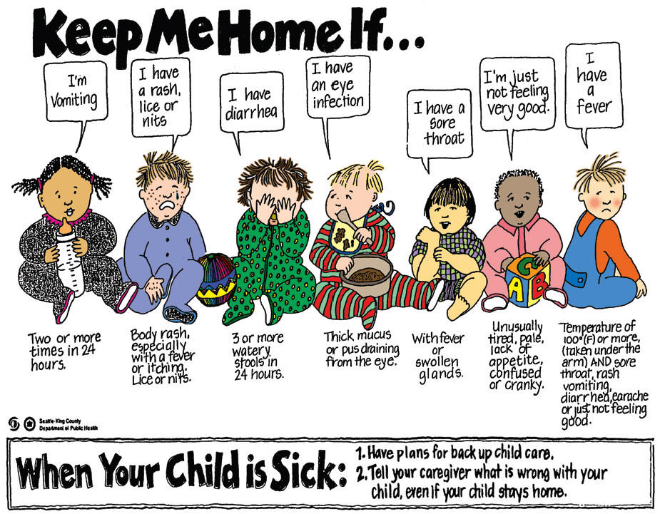

Medication
All medications, prescription and non-prescription, must be kept in its original container with expiration dates marked. All prescriptions must have the child’s name, physician name, medication name, description and directions on the label. All medications will be dispensed according to the labeled instructions or manufacturer’s label. No medication that is expired or under someone else’s name will be administered. ALL medication must be logged and given to the Director or designated staff member. No medications will be kept in the classroom*. The Medication Administration form must be filled out for each medicine with an expiration date. Any change must be in writing.

*Please note, children with asthma may keep an inhaler with them or in the classroom provided a Medication form is on file in the child’s folder and a note/prescription from a doctor is provided.

Emergency Procedures and Notification
For the safety and well-being of the children in our care, emergency telephone numbers, including the Florida Abuse Hotline, will be posted by each telephone and on our bulletin board.

Parents/guardians will be notified in the event of any serious illness, accident, injury or other emergency. In the event a parent or guardian cannot be reached, those designated on the enrollment form will be contact and any written instructions provided upon enrollment will be followed. If it is determined immediate emergency care is required 911 will be called an appropriate actions will be taken.

Inclement Weather/Disaster
Orlando Children’s Academy will follow the Orange County School’s inclement weather closings. If the county decides schools should be closed or early dismissal is necessary our center will follow those guidelines. In the event early dismissal is necessary we will notify parents by phone as soon as the decision is made. Orlando Children’s Academy is not responsible for any incurred fees or monies due to this decision. Please understand this is for the safety and well-being of our students and staff. All regular pick up procedures still apply.

Sick Child Policy
Children who are sick or exhibiting the symptoms listed below should be kept out of the center until the symptoms are gone (a fever must be gone for 24 hours) or a doctor has cleared him or her for return. If your child becomes ill during the day with the symptoms listed below the child will be taken to an isolation area and you will be called to pick up your child within one hour.

Symptom/Illness List
Fever – 100.5 or above
Severe coughing with or without mucus
Wheezing
Difficult or labored breathing
Rash/Hives or spots
Conjunctivitis (pink eye)
Sore throat, difficulty swallowing
Diarrhea (more than normal loose stools)
Lice
Vomiting
Abnormal fatigue, malaise or fussiness

Please note this list is a general list and not comprehensive of all illnesses. Staff will determine when a child needs to be isolated.

Infection Control
In a child care center children will continuously come in contact with other children. Germs are spread easily and rapidly in this type of setting. For this reason our staff will take every precaution to promote infection control. This will include isolation of any sick children, frequent hand washing, daily sanitization of toys, play areas, changing tables, bathrooms and other common areas.

Smoking Policy
Orlando Children’s Academy and premises are considered NO SMOKING ZONES. Smoking by staff and/or parents is prohibited at all times.

Emergency Drills and Procedures
Orlando Children’s Academy will hold monthly fire and tornado drills for the purpose of familiarizing both staff and children with what to do in an emergency.
In the event of a real emergency, each teacher will verify attendance to make sure all children are accounted for and give aid and comfort as needed. Your child’s safety will be our first priority. You will be notified, and we will move the children according to the Emergency Relocation Plan designated in the Security Section of this handbook until you are able to get away to pick him/her up.

Accident/Incident/Injury Reporting
(See attached Accident/Incident/Injury Form)
Should an accident or something unusual happen while your child is at the center, you will be notified. If the child sustains an injury to his/her head, no matter how small it may appear, or incurs a serious injury, we will call you immediately. If the injury or incident is minor, we will inform you when you come to pick up your child.

CPR and First Aid
Most OCA staff members are certified in CPR and First Aid. First aid kits and emergency exit plans are located in all of the early childhood classrooms and vehicles.
The center will provide the following non-prescription medications and products to your child, with your signed permission at enrollment, according to the manufacturer’s instructions or otherwise specified in writing.
Baby powder Baby oil Baby lotion Itching creams
First aid spray Calamine lotion Cold creams Suntan lotion
Head lice shampoo Insect repellent Rash ointments Teething Meds
Vaseline Antiseptic and burn ointments Antiseptic wipes

Lost Children
In the unlikely event that a child should become lost, staff will notify parents/guardians immediately and the proper authorities will be notified by phone and written forms.

Discipline Policy

At Orlando Children’s Academy our goal is to provide a loving, nurturing environment. We believe positive reinforcement should be used to develop appropriate behavior and actions of children. No child will be humiliated or subject to discipline that deprives him of rest, food or toileting needs. Spanking or other corporal discipline is never allowed. Our goal is to gently correct children and help them learn circumstances relevant to choices, and to help each child control his own behavior and temper without fear of neglect or abuse.

Discipline is used in the following situations:
- Children are not permitted to cause harm to themselves, other children, visitors or staff members.
- Children are not permitted to humiliate, bully or belittle others in any way.
- Children are not allowed to damage center property or the property of others.
- Biting: While biting does occur among children our staff will strive to prohibit this from happening. If a child bites another child all procedures will be followed as normal and a Discipline Report will be filled out with parent’s signature required. If biting occurs frequently your child may be asked to dis-enroll from Orlando Children’s Academy.

Orlando Children’s Academy will strive to use techniques to ensure that discipline problems are avoided if at all possible. Staff will treat all children with respect, as well as family members, visitors and other staff. Activities will be planned to avoid boredom and non-activity. Classrooms will be organized and calm atmosphere will be encouraged. Clear and consistent standards will be expected for each child.

In the event a staff member must intervene, the following procedures will be followed:
- Children will be given an explanation as to why their behavior or actions are not appropriate.
- Children will be given the chance to express themselves in a calm way.
- Children will be given directions in a way that is not humiliating or belittling, that allows them to choose an appropriate behavior.
- Children will understand in a clear and concise way that their behaviors and actions, should they continue, will have negative consequences.
- Staff will encourage and redirect the child into a different activity or area that may be less stimulating.
- As a last resort, staff may remove a child from the classroom into the Director’s care. At this time the Director will determine if parental notification is necessary. The Director will decide when the child can return to class or if a parent must pick up the child (in extreme circumstances only).
- At any time a child is removed from the classroom a Discipline Report will be filled out with a copy to the parent and one for the file.
- If inappropriate behavior or actions of a child is a continual problem the Director may deem a parent/teacher conference is necessary. If the inappropriate behavior or actions continue beyond this measure the child may be asked to disenroll from Orlando Children’s Academy. If a child is asked to leave our center no fees or tuition will be refunded and any costs for damages will be the responsibility of the parent.
Incident / Behavior Form

Date: ________________

Child’s name: ___________________________
Type of Incident: (Check one) Incident Accident Illness Behavior

Time of incident: ____________ AM / PM Where it happened: _______________________________
Please describe the Incident / Accident / Injury:
Parts of Body Involved

Type of treatment Administered / Action Taken

Name of Parent Notified: _________________________________ Time: ______________

Type of Illness: _________________________________________________

Action taken by staff: ___________________________________________________________
Type of behavior: _______________________________________________

Action taken by staff: ___________________________________________________________
Corrective Action Needed to Prevent Reoccurrence

_____________________________ _________ _____________________________ ___________

Staff’s Signature Date Director’s Signature Date

________________________ _______
Parent’s Signature Date

Medication Authorization Form
(Medication Must Be In Original Container)

Child’s Name: ________________________________________________
Medication: _________________________________________________
Dosage Amount: ________________________________________
Time to be given: ________________________________________

Side Effects/ Anticipated Reactions: ____________________________________________________
_________________________________________________________________________________
Special Instructions (if applicable): _____________________________________________________
_________________________________________________________________________________
I have determined the staff of Orlando Children’s Academy competent to give or apply medication to my child(ren).

______________________________________________________________________________________________
Signature of Parent/Guardian Date

*** If all information is not filled out completely, medication will not be given.
Administration Documentation
Date Given | Time Given | Dosage Given | Staff Signature

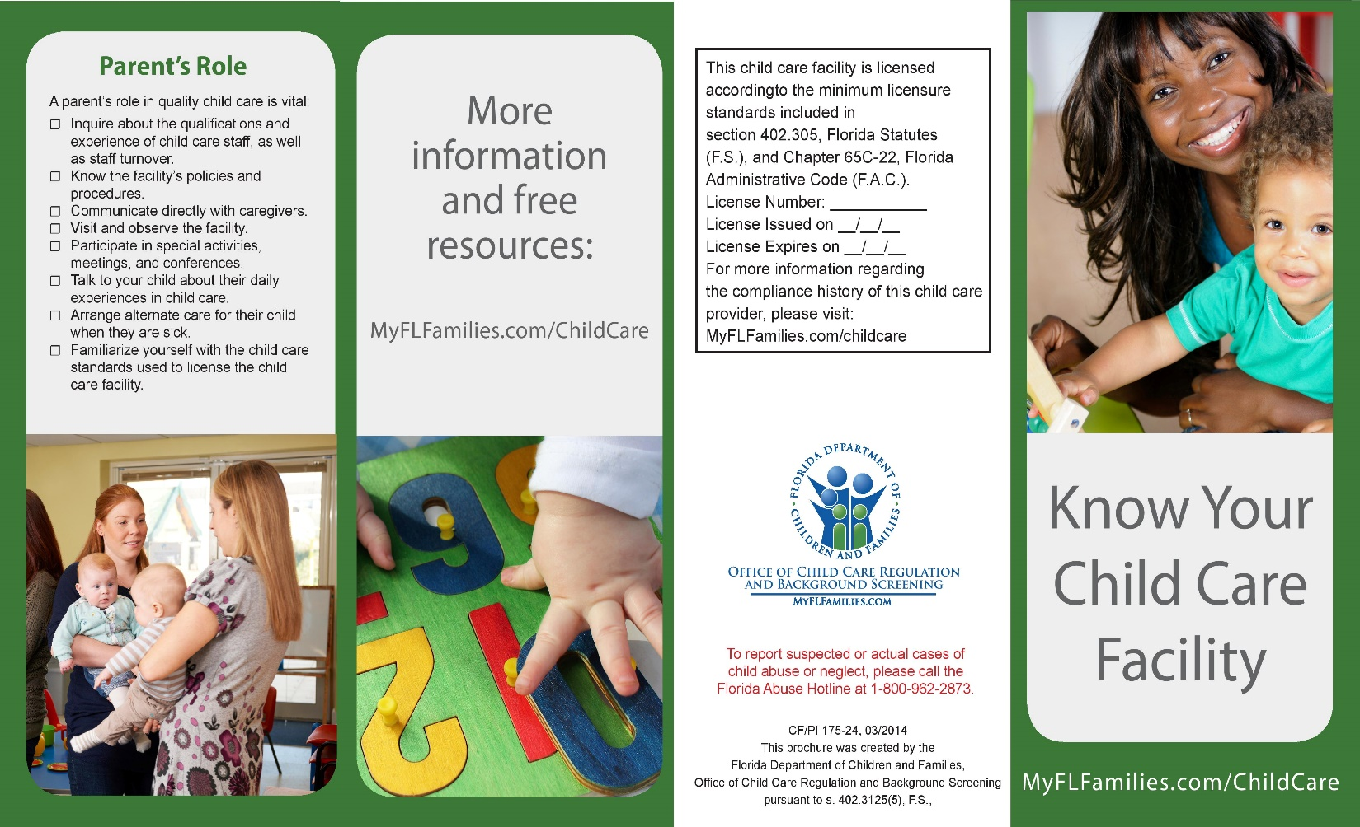

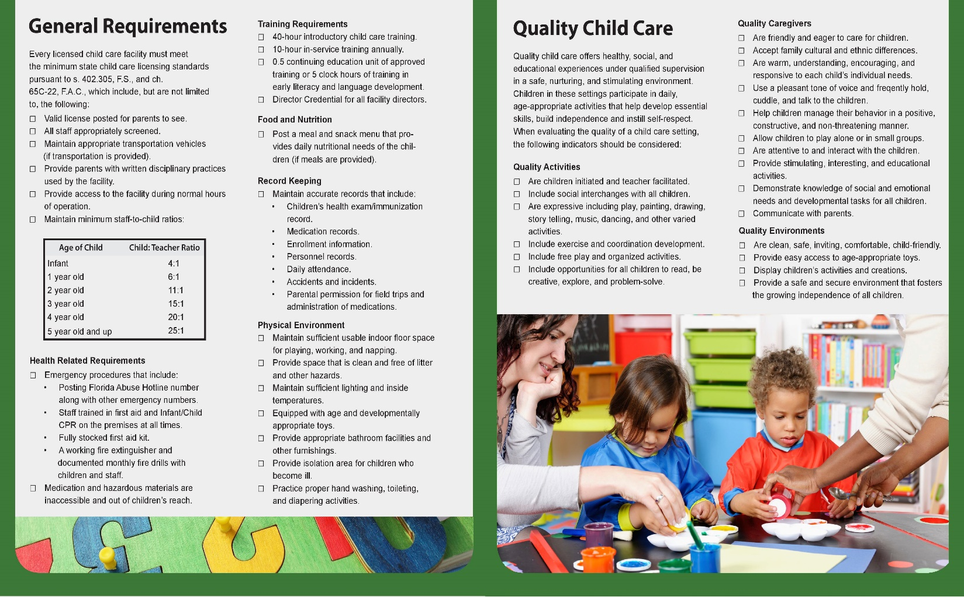
Parent Acknowledgement of Enrollment Policies & Procedures

- Our Philosophy & Goal for your Children
- Tuition & Fee Schedule
- Notification of Policy Changes
- Days & Hours of Operation
- Attendance / Absences
- Illness / Injury
- Medication Policy
- Naptime
- Release of Children
- Appropriate Dress
- Meals & Snacks
- Guidance and Discipline
- Parental Responsibilities
- Transportation
- Animals
- Child Care Licensing Information
- Emergency Evacuation and Relocation Plan
- Parental Involvement and Volunteers
- Grievances and Complaints
- Parent Acknowledgement of Policies

- I have read each of the above items and understand the policies and procedures of the Orlando Children’s Academy.

As a parent with a child(ren) enrolled at Orlando Children’s Academy, I affirm that I have received and understand the policies and procedures contained in the Parent Handbook and agreed to abide by same.

Parent’s Signature: _____________________________________

Child(ren)’s Name: _____________________________________

Date: ________________________

We are required by Florida Department of Children and Families to have this form with your enrollment papers to be kept in your child’s file at Center. Thank you for your understanding & cooperation.

