
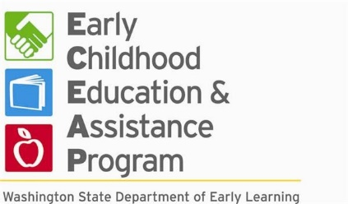

Parent Handbook
  - Early Childhood Education and Assistance Program (ECEAP)
  - A program of Community-Minded Enterprises



Table of Contents
Mission, Focus, and Values Statements 4
What is ECEAP? 5
Contact Information 5
Non-Discrimination 6
Confidentiality 6
Fraud 6
Classroom Information 6
Typical Daily Schedule 6
What to Bring to School? 7
Dressing for School 7
Staff to Child Ratio 8
Curriculum 8
Enrollment 8
Attendance 8
Drop Off and Pick Up 9
School Closures 10
Holidays and Celebrations 10
Field Trips 10
Classroom Photos 10
Early Achievers 11
Parent/Guardian Access to Children 11
Nontraditional Remote Services 11
Children Services 11
Child Assessments 11
Individualization 12
Developmental Screenings 12
Inclusive Environment 12
Child Guidance 13
Transitions 15
Transportation 15
Nutrition Services 15
Meals/ Snacks 15
Family Style Meals 16
Nutrition and Physical Activity 16
Health and Safety Services 16
Illnesses 16
Injuries/ Medical Emergencies 17
Medications 17
Individual Care Plans 17
Immunizations 17
Health Screenings 17
Mental Health 18
Cleaning/ Disinfecting 18
Contagious Disease Prevention, Policy, and Procedure 18
Disaster and Emergency Preparedness 18
Mandated Reporter Policy 18
Pesticide Notification 18
Drug and Weapon Free Environment 18
Pets/Animals 19
Parent/Family Services 19
Communication 19
Access to Student Records 20
Where to Find Required Postings 20
Ways to Get Involved 21
Parent Resources 22
Air Quality Guide 25
Child Care Weather Watch Chart 27
References 29

Mission, Focus, and Values Statements

MISSION

Community-Minded Enterprises (CME) empowers communities to improve long term well-being. CME carries out this mission through outreach, access, and training.

FOCUS

CME focuses its work on:
- Increasing local access to state and national services
- Ensuring community voices at regional and statewide initiatives
- Leading state-wide outreach to low-income, multi-ethnic, and marginalized communities through partnerships with trusted messengers
- Offering individualized services and training under innovative projects to evaluate strategies and help change policy to overcome barriers
- Empowering community voice through digital media

VALUES

We want to be known as a workplace that values family life and flexibility. We are community focused. These values are the foundation for our work internally and externally.
- We operate in an equitable, inclusive & culturally relevant manner.
- We believe in opportunity.
- We are respectful, professional & open-minded.
- We follow through on commitments that produce measurable outcomes.

What is ECEAP?

“The Early Childhood Education and Assistance Program (ECEAP) is Washington State’s preschool program that supports children and families who are furthest from opportunity. ECEAP provides high-quality comprehensive services that focus on the whole child. Children receive individualized, child-centered services including education, health coordination and family support services.”
We will:
- “Provide a comprehensive pre-kindergarten program that integrates education, family support and health services
- Foster the development of the whole child and enhance opportunities for success in school and life
- Focus on parent and family strengths and support each parent as their child’s first and most important and provider of safety, loving care, and stability.
- Honor each family’s culture and language and ensure culturally relevant services.”

(Washington State Department of Children, Youth, and Families, 2023, p.6).

Contact Information

Each CME ECEAP location has a Direct Service Team which includes the following roles:
Associate Director of ECEAP and Family Services: Oversees and directs all of CME ECEAP.
ECEAP Manager: Directly supervises ECEAP staff at all sites
Lead Teacher: Leads the classroom, childcare, lessons, facilitates parent-teacher conferences
Assistant Teacher: Assists the Lead Teacher in the classroom
Aide: Assists the Lead and Assistant Teachers in the classroom
Family Support Advocate: Will help you with enrollment, family goals, find resources, and more
Classroom | Address | Phone Number | Ages Served
South Hill Class #1 | 3307 E. 55th Ave Suite B  Spokane, WA 99223 | (509) 951-7435 | 3-4 years
South Hill Class #2 | 3307 E. 55th Ave Suite B  Spokane, WA 99223 | (509) 951-7435 | 4-5 years
Lower South Hill | 1722 E. 32nd Ct.  Spokane, WA 99203 | (509) 951-3680 | 3-5 years
Peaceful Valley | 214 N. Cedar St.  Spokane, WA 99201 | (509) 951-3680 | 3-5 years

Non-Discrimination

No person shall be subjected to discrimination against race, ethnicity, color, national origin, sex, sexual orientation, gender identity, gender expression, age, religion, culture, creed, marital status, family configuration, citizenship, ancestry, ability, health, veteran or military status, stages of child development, or public assistance recipient status. This policy applies to CME ECEAP programs, policies, activities, social services and employment practices. All CME ECEAP staff review and are trained on the non-discrimination policy prior to starting classes. All CME ECEAP staff receive annual training on Anti-Bias and Inclusion as well. If anyone believes they have been discriminated against, they should follow the complaint procedure on page 19.

Confidentiality

Community Minded ECEAP programs will hold student and family records and information in strict confidentiality. Parents/guardians may view files related to their own child during scheduled hours of operation. School staff will view and use student and family information only for care and instructional purposes and will hold that information in strict confidentiality. Confidential student and family information will not be released to or shared with third parties without the written consent of parents/guardians.

Fraud

ECEAP is a state funded program. Eligible families benefit from participating in the program. Families must meet specific requirements as defined in section PAO-38 of the performance standards in order to be eligible for the program. If participants intentionally provided false information, it could jeopardize their child’s eligibility and continued enrollment in the program.

Classroom Information

Typical Daily Schedule
The class schedule will be given at time of enrollment/ orientation to the program. The schedule may be adjusted to meet the needs of the children. If any changes are made throughout the year, a new class schedule will be given to each family. Below is a sample daily schedule.

- Arrival
- Snack and Toothbrushing
- Music and Group Time
- Free Choice and Active Play
- Bathroom
- Outdoor Play
- Bathroom
- Story
- Lunch
- Bathroom
- Rest Time
- Free Choice and Small Groups
- Afternoon Snack
- Dismissal

Toothbrushing
Toothbrushing is a part of the daily schedule at each CME ECEAP location. Toothbrushing is a requirement in the ECEAP Performance Standards (ENV-14). This part of the schedule will take place after a meal or snack with water and can be adjusted to meet the individual developmental needs of the children. CME ECEAP toothbrushing will not involve toothpaste. CME ECEAP will provide toothbrushes for each child to use in class.

Outdoor Play
Each CME ECEAP class will have outdoor play almost daily unless recommended otherwise by the Air Quality Guide or Child Care Weather Watch Chart on pages 25 and 27. A minimum of 60 minutes of active outdoor play and 30 minutes of active indoor play is required daily for all early learning programs that operate for longer than 6 hours according to WAC 110-300-0360. (See Dressing for School).

Rest Time
Rest time is a part of the daily schedule at each CME ECEAP location. Rest time is required for all early learning programs that operate for longer than 6 hours according to WAC 110-300-0265. All CME ECEAP Classes run for 6.5 hours. During rest time, each child will have their own cot and blanket and will be given the opportunity to take a nap. Children who do not nap will have a quiet time and be given activities that don’t disrupt sleeping children such as picture books or puzzles.

What to Bring to School
- An extra set of clothes labeled with your child’s name to be left in their cubby (in case of an accident or mess)
- If your child is in the process of toilet training: at least 2 changes of clothes
- Coats, hats, gloves, and boots when weather appropriate

*Please leave backpacks, outside food, and personal toys at home

Dressing for School
Plan on dressing your child for a day of fun and activity which includes encounters with paint, markers and other things that may stain clothes. Comfortable, casual clothing are shoes safe for running are best. Please also dress your child in clothing that matches the weather conditions, such as coats, hats, gloves, and boots when there is cold weather or snow. Each CME ECEAP class will go outside daily, rain or shine, unless recommended otherwise by the Air Quality Guide or Child Care Weather Watch Chart on pages 25 and 27 (See Outdoor Play, p.7). If appropriate shoes or clothing are not available, parents may be called to drop some off. If your family does not have these items, please talk to your Family Service Advocate for resources.

Staff to Child Ratio
Washington State Administrative Code (WAC) 110-300-0357 requires a 1:10 staff to child ratio in early learning programs serving children 36 months through kindergarten. This means there will always be a minimum of 1 teacher per 10 children in CME ECEAP classes. For example, a class with anywhere from 11- 20 children will have a minimum of 2 teachers present at all times to meet this 1:10 ratio.

Curriculum
The Creative Curriculum for Preschool is a high-quality, developmentally appropriate curriculum that supports the daily lesson planning and intentional classroom arrangement in CME ECEAP classrooms. Creative Curriculum is based on the importance of positive student-teacher relationships and teacher-family partnerships, child-led exploration and learning through play, and social-emotional skill building. This curriculum is designed to support social-emotional, physical, language, cognitive, literacy, and mathematics development and learning, as well as English language acquisition.

Conscious Discipline is a trauma informed social and emotional curriculum that leads the behavior management and classroom structures in CME ECEAP centers. Conscious Discipline is guided by three beliefs: “Controlling and changing ourselves is possible and has a profound impact on others, Connectedness governs behavior, and Conflict is an opportunity to teach,” (Bailey, 2015, p.15). This curriculum is designed to support positive social and emotional development, reduce challenging behaviors, and provide trauma-informed care.

All CME ECEAP teachers have completed general training on Creative Curriculum and Conscious Discipline and receive ongoing coaching on these curriculums. Note- CME ECEAP may supplement with additional social-emotional curriculums as needed.

Enrollment
All CME ECEAP services are free of charge to eligible families while enrolled. CME ECEAP will maintain current files for each enrolled student- referred to as the “child’s file” throughout this handbook. Paperwork for this file will be filled out at enrollment with your Family Support Advocate. Any 2nd year parents must review and update all items in their child's file at the start of each new school year in August. This enrollment process must be completed before the child attends their first day of school. If a parent/guardian intends to withdraw their child from the program, they will be asked to complete a withdrawal request to keep on file.

Attendance
Regular attendance is important for children’s learning and future success in school. When attendance is consistent, children make more progress, have reduced stress, and gain a better sense of belonging and safety in class. ECEAP Performance Standards require all enrolled children to attend class at least 85% of the time. This amounts to a limit of 3 unexcused absences per month. If 3 unexcused absences occur, the Family Support Advocate will meet with the parents/caregivers to create an Attendance Plan. The Attendance Plan’s intent is to support improved attendance within 30 days. If attendance does not improve within that time frame, the child will be disenrolled from the program and CME ECEAP will enroll the next child on the classroom’s waitlist.

To avoid unexcused absences- communication with your direct service team is key! Text or call your Lead Teacher and/or Family Support Advocate if your child will not be attending school that day.

Some examples of EXCUSED absences are:
- Doctor, dental, or therapy appointments
- Illness
- Vacation

If your child does not attend school and the Direct Service Team has not heard from you, they will text or call you to check in. However, the absence will be considered unexcused if there is no response given to CME ECEAP.

Drop off and Pick Up
All CME ECEAP classes start at 8:00 am and end at 2:30 pm.
At drop off and pick up be prepared to:
- Accompany your child to wash hands before entering the classroom
- Sign-in and sign-out your child before leaving the facility
- Provide photo ID

Plan on dropping your child off at 8:00 am. Unless prearranged with the Lead Teacher and Family Support Advocate at least 1 day before, no families will be allowed to drop off after 8:15 am. At 8:15 am, the doors are closed and only families with an appointment will be allowed entry to ensure the safety of the school. Routine is very important for early childhood development. Late arrival not only takes valuable resources and learning time away from your child, but it also disrupts the routine and learning of their classmates. If there are barriers to getting your child to school on time, we encourage you to work with the Family Support Advocate to discuss resources to ensure consistent attendance and on-time arrival.

Plan on picking your child up from school at 2:30 pm. Be mindful that staff members are not available to care for children outside classroom hours. If you are running any later than 10 minutes past 2:30, text or call your Lead Teacher and/or Family Support Advocate to let them know to ensure proper staff coverage. If staff have not heard from you, they will attempt to contact you (the parent/guardian(s)) via call and text. If staff are unable to reach the parent/guardian(s) after 20 minutes, they will attempt to reach the emergency contacts/ alternative pick-ups you provided. After 30 minutes, if CME ECEAP has not successfully reached any approved contacts, staff are required to call law enforcement as mandated reporters. If late pick-ups occur on a regular basis, you will need to meet with your Family Support Advocate to create an Attendance Plan (See Attendance, p.8).

CME ECEAP will only release your child to:
- The guardians you list on your enrollment paperwork
- The parents listed on the birth certificate
- The approved people you list on the alternative pick-up form

All this paperwork is filled out with you and your Family Support Advocate upon enrollment and will be kept in your child’s ECEAP file on site. Anyone who is at least 16 years old and with a photo ID may pick up your child with your written approval. If you want to remove permission for a birth certificate parent to pick up, certain paperwork must be provided- See your Family Support Advocate for more information. You may add or remove pick up and drop off permissions at any time. To do this, you must meet with your Family Service Advocate to update the required form in your child’s file (this may be done before drop-off, if necessary). The changes will not be considered valid and the staff will not be allowed to adhere to them until the child’s file is updated with your signature.

School Closures
CME ECEAP classes run from late August through mid-June and are closed for the summer. Classes take place on Mondays through Thursdays, with no school on Fridays. All families will receive a CME ECEAP school calendar at enrollment. CME ECEAP will follow District 81 school closures in most circumstances. If District 81 closes due to weather, CME ECEAP will also be closed. When CME ECEAP classes need to close, families will receive a text message notifying them of the closure. It is important that caregivers check their phones in the morning, so they do not miss these notifications.

Holidays and Celebrations
CME ECEAP’s calendar recognizes all federal holidays for closures. However, this program provides all services based on need, not creed. Religious holidays and traditions will be respected, but CME ECEAP will leave the religious holiday celebrations to you. Individual beliefs will be discussed with sensitivity and respect for diversity within the classroom setting.

Field Trips
Field trips are rare but in the case of additional funding, CME ECEAP may plan field trips and need to transport students off-site. Parents must provide a signed field trip permission form for their children to participate in an off-site field trip. The field trip form will list the field trip location, hours, and activities, and will state the means of transportation to be utilized. Field trips will normally take place during regular school hours, 8:00 am to 2:30 pm. During field trips, CME ECEAP staff will supervise and care for children; parent/guardian(s) who participate in field trips will care for and supervise their own children. Supervising field trip staff will always have with them the following: student roster, consent for treatment & emergency contact forms for all students, and a complete first aid kit. In the case of emergency, all staff and students will seek appropriate shelter, follow the directions of emergency service personnel, and will contact parents by phone. Any fees required for off-site field trips will be paid by CME ECEAP.

CME ECEAP- South Hill classes will be walking down the sidewalk to the 55th Avenue Apartments playground daily for outdoor play. CME ECEAP staff will ensure the playground is safe by conducting a daily inspection of the playground before the children walk over as a group to use the area. The permission slip for this ongoing trip off-site is a part of the enrollment packet.

Classroom Photos
With parent/guardian permission, CME ECEAP staff will take photos and videos of children while at school. These photos and videos are used for the following:
- To document and observe children’s learning and development throughout the year
- To send parent/guardian(s) updates on their child during the day
- To post in the classroom for the children to see
- For print or electronic media to promote CME ECEAP
- For staff training purposes

Early Achievers
Quality childcare and early learning programs help children enter school ready to succeed. Washington Early Achievers is a program that:
- Provides families with information about the quality of care through a 1 through 5 rating system
- Offers childcare programs resources like coaching and training so they can support children’s learning and development
- Offers opportunities for ECEAP to gain recognition for the high-quality services they provide and to be leaders in supporting quality of services across settings by sharing resources and expertise with childcare partners

CME ECEAP, as a participant in Early Achievers, might receive on-site evaluation visits from Early Achievers coaches. The purpose of the evaluation visit is to observe and gather information about the site to provide teaching support and create an Early Achievers Rating.
This process includes:
- Observing the early learning environment to learn about the materials, activities, and experiences available to support children
- Observing interactions between teachers and children

Parent/ Guardian Access to Children
For the safety of CME ECEAP children and staff the outside doors will be locked during class hours. However, we are an open-door facility and parents may call a member of the Direct Service Team to unlock the door at any time to have access to their child. Parents/guardians are asked to respect and empower the educational setting and process by planning and limiting unexpected interruptions of the school day. If any family member would like to regularly volunteer and be a part of the classroom, they must fill out the required paperwork with the Family Support Advocate (see Volunteering for ECEAP, p.22).

Non-Traditional Remote Services
In the case of temporary unforeseen circumstances that get in the way of CME ECEAP’s ability to provide traditional services, the program will continue to provide education, health, and family support services to enrolled families through non-traditional remote methods. Educational services may be provided through apps like Ready Rosie, video calls, no-contact picking up or dropping off of learning materials. Health and family support services will be provided by the Family Support Advocates through virtual meetings: phone, video call, etc. For more information contact the CME ECEAP Director.

Children’s Services

Child Assessments
CME ECEAP uses Teaching Strategies Gold (TSG), an online documentation system, to complete regular informal and formal assessments of each student’s development and learning in the following areas: social-emotional, physical, language, cognitive, literacy, math, and language acquisition. These assessments are done for each child who has attended the class for at least 90 days. Formal assessments will be completed in TSG each quarter (3 times a year) based on daily informal assessments of children which will be recorded in TSG. Observations are documented by the Lead and Assistant Teachers throughout each class day while children are interacting with learning materials. These may include, but are not limited to, anecdotal, work sampling, observations, pictures, and videos. Both informal and formal assessments results will be shared with caregivers during 3 parent-teacher conferences that will be scheduled each quarter after the formal assessment (checkpoint) in TSG is completed. All CME ECEAP teachers have completed general training on TSG and receive ongoing coaching on this assessment tool. All Leads and Assistants have also completed their Interrater Reliability Certification.

Individualization
Learning goals will be developed for children based on TSG class observations and assessment results, home observations, and ASQ-3 screening results. CME ECEAP teachers will work with caregivers to review and discuss the observations, screenings, and assessments during conferences, determine the child’s strengths and needs, and make individual learning plans for school and home.

Developmental Screenings
Developmental screeners are a crucial part to children’s education, so it is a requirement for each child enrolled in ECEAP to receive a developmental screening within 45 days of their first day in class. Developmental screening allows the teachers to observe and track where the classroom is at, and where each child is on an individual level. All of the screeners used at CME ECEAP are developmentally and culturally appropriate, as well as valid and reliable.

The two developmental screeners CME ECEAP uses are the Ages and Stages Questionnaire or ASQ-3 and the Ages and Stages Questionnaire: Social-Emotional or ASQ: SE-2. The ASQ-3 screens communication, gross motor, fine motor, problem-solving, and personal-social development. The ASQ:SE-2 screens social-emotional development. These are meant to be completed by the parent or guardian of the enrolled child, however, the teaching staff can assist in completing the questionnaire, if needed. The ASQ-3 is offered in English, Spanish, and Arabic and CME can provide translation services for anyone who needs. Lead Teachers have received training to administer the ASQ-3 and ASQ:SE-2. When the screenings are completed, the Lead Teacher will calculate the results and schedule a follow-up meeting with you to discuss the results and any questions or concerns about your child’s development. If needed, an interpreter may be present, and the results can be translated to another language. Should there be any concerns regarding your child’s development, either from you or the Direct Service Team, your child may be referred to Spokane Public Schools for further evaluation to determine the need for an Individualized Education Program (IEP).

Inclusive Environment
CME ECEAP works to ensure all enrolled children and families receive high-quality childcare and comprehensive services. CME ECEAP staff individualize services based on the families’ needs. Gender identity expression, cultural relevance, diversity, dual language learning, and varying abilities are all considered to create strength-based and individualized support and teaching.

Disabilities/ Special Needs
All children enrolled in CME ECEAP will receive a developmental screener within their first 45 days of school. This screener may identify areas of development that could need further evaluation. If families or CME ECEAP staff have concerns about a child’s development, they may decide together whether they want a referral for the child to receive an evaluation for an IEP.
CME ECEAP staff will partner with families to create an Individual Care Plan for any children with a disability or special needs (See Individual Care Plan, p.17).

Dual Language Learners
For families whose first language is not English, CME ECEAP will do the following:
- Include each child’s home language in the classroom (signs, books, music, etc.)
- Use a picture communication app in the classroom to communicate with non-English speaking children
- Work with community agencies to access interpreters
- Translate written communications into home language as requested
- Hire volunteers/ staff who speak the home languages of enrolled children when possible

Toilet Training
Teachers will work with families to support enrolled children who are not yet toilet-trained, as developmentally appropriate. Toilet training will include positive reinforcement, be culturally sensitive, will not use foods as a reinforcement, and will follow a routine established between CME ECEAP and parents/caregivers. CME ECEAP uses Great Value Pull-ups and Wipes. If your child has a sensitivity to this brand, you may fill out a Medication Authorization form with your FSS and provide your own pull-ups and wipes.

Child Guidance
CME ECEAP’s goal for children’s behavior is that children learn self-control and respect for others. We understand that children will practice behavior as they would practice learning any skill. Our job as your child’s teachers is to support children in learning skills such as self-regulation, empathy, problem-solving, listening, and communication that lead to self-control and respect for others. CME ECEAP staff teach these social and emotional skills through Conscious Discipline (See Curriculum, p.8). All CME ECEAP staff receive annual Conscious Discipline training at a minimum as well as ongoing coaching on best practices in instruction and behavior management. CME ECEAP staff will also have access to CME’s Infant and Early Childhood Mental Health Consultant, who can provide support as needed.

The behavior guidance policy for CME ECEAP will be followed by all classroom staff, volunteers, and families always, and in all areas of each childcare site.

Conscious Discipline uses a positive guidance approach that involves the following steps:
- Notice and empathize
  - Vocally describe what you observe a child is doing and acknowledge how they might be feeling
- Co-regulate
  - Redirect to safe place if necessary
  - Model and support the child to belly-breathe
  - Model and support calm-down activities like stretching, counting, using sensory materials
- Problem-solve
  - Give 2 safe choices
  - Logical consequences
  - Model and guide child to communicate with peer
Supervision: CME ECEAP teachers will maintain a 1:10 ratio at all times. If 1 child needs a moment outside of the classroom when there are over 10 students present, 1 teacher will guide, while 2 others supervise the classroom.

Restraint: CME ECEAP staff will not use restraint to manage behavior. If a child’s behavior is not successfully deescalating through our positive guidance approach, the teachers will guide the rest of class out of the classroom for an alternative activity while at least 1 teacher remains with the escalated child in the classroom until they calm down.
.
The following actions are prohibited at all CME ECEAP locations:
- Corporal punishment, inflicting pain, or bodily harm of any kind (spanking, striking, shaking, etc.)
- Physical force/ Holding, grabbing, or moving children in an aggressive manner
- Physical restraint that could cause bodily harm
- Isolation of a child in a closed or locked space
- Verbal abuse or any language that is threatening, humiliating, or frightening (yelling, shouting, name calling, shaming, making derogatory remarks)
- Using foods or liquids as punishments or rewards

No Expulsion Policy
CME ECEAP is a No Expulsion preschool. This means that CME ECEAP classes will not expel or suspend children for any reason. If a child is exhibiting challenging behavior, staff will work extensively with the family and child to support the child by seeking out community resources, meeting with the family and setting goals, maintaining consistent teaching practices with the child in the classroom, and any other resource to ensure the child is successful in the classroom and at home.

Child Focus Response Plan
If a child is exhibiting challenging behavior on a regular basis, the CME ECEAP staff will work with and support the child and their family by following these steps:
- The Direct Service Team will track observations of the child and the challenging behavior on a Behavior Tracking Form that records the why, when, how, where, and with who of the situation
- The Direct Service Team will reflect on observations with the child’s parent/caregiver(s) to help identify the behavior’s cause (triggers, unmet needs, missing skills)
  - CME ECEAP may partner with an Infant and Early Childhood Mental Health Consultant and/or an Educational Coach to conduct observations and reflect
- The Direct Service Team in partnership with the child’s family and the Consultant/Coach will create a Child Focus Response Plan to set goals for the child and adapt the classroom environment, instruction, and/or materials to support the child’s needs
*CME ECEAP teachers will discuss any services they would like to use to support the child and family in the classroom with the family before any consultations take place.

No Violence Policy
If a child exhibits unsafe behavior that includes bodily harm towards staff and/or peers regularly, an Infant and Early Childhood Mental Health Consultant will do an observation. Next, the Direct Service Team will meet with the parent/guardian(s) to create a Child Focus Response Plan that may include an Alternative Attendance Plan. These plans will give the child an adjusted schedule to reduce the child’s observed triggers and increase safety in the classroom. This schedule may include reducing time in the classroom through offering services in an alternative space if possible, or at home.

Transitions
Your children will experience various transitions when they begin attending school. CME ECEAP staff will partner with families to support children and parents/guardians during these transitions and work to give them a positive experience. Below are some services CME ECEAP will offer to support families in educational transitions:
- Enrollment in CME ECEAP: the Family Support Advocate and Lead Teacher will facilitate a site tour, orientation, enrollment, and home visit.
- Transfer to New CME ECEAP Classroom: Family Support Advocate and Lead Teacher will facilitate the family’s introductions to the new classroom and teachers as well as transfer of information.
- Transfer to or from another Early learning program: Family Support Advocate and Lead Teacher will connect with the new site’s staff and facilitate the family’s introductions to the new teacher, support staff, and classroom as needed. CME ECEAP’s Family Support Advocate may assist the family with enrollment as requested.
- IFSP or IEPs: Family Support Advocate and Lead Teacher may support families as requested to attend meetings and discuss options when developing or transferring to an IEP.
- Transition to Kindergarten: Family Support Advocates work to connect with local schools as well as provide info to families about kindergarten registration, assist families in registering for kindergarten, and connect families to kindergarten readiness events and orientation at their new school. Lead Teachers will provide kindergarten readiness information to families and work to connect with the kindergarten’s principal and teachers. With parent/guardian permission, Lead Teachers may share assessments and information about the child with new teachers to support their transition to the classroom. Family Support Advocates and Lead Teachers may attend meetings at the new school with families as requested.
You can find on CME ECEAP’s schedule the following events to support these families with these transitions: home visits, orientation, open house, Kindergarten round-up, and kindergarten readiness family events. For more information, see the Family Support Advocate or Lead Teacher.

Transportation
Currently, transportation is provided by parent/guardians only. If any changes are made, all families will be notified.

Nutrition Services

Meals/ Snacks
CME ECEAP partners with the U.S. Department of Agriculture (USDA) Child and Adult Care Food Program (CACFP) in order to provide quality nutrition standards for your child. We serve the following meals at no additional charge to you:

- AM Snack- 2 of the following choices: complex carbohydrate, fruit, veggie, protein
- Lunch- Milk (or substitute), fruit, vegetable, complex carbohydrate, and a protein
- PM Snack- 2 of the following choices: complex carbohydrate, fruit, veggie, protein

If your child has any allergies or cultural dietary preferences, please inform the staff and note it on the Individual Care Plan form in the enrollment package. All CME ECEAP teachers who handle or serve food have a current Food Worker’s Card.

Family Style Meals
Like the rest of class time, mealtime is a learning opportunity for the children where they can practice language, social, and fine motor skills. During mealtimes in the classroom, the teachers will sit with the children and engage them in conversations. The teachers will facilitate “family style meals” which means the food will be set up for the children to practice serving themselves and cooperating with each other. The children will be introduced to new foods and are encouraged to try them.

Nutrition and Physical Activity
CME ECEAP promotes healthy eating habits, healthy movements, and physical activities. During meals and snacks, teachers teach children about healthy foods and talk about nutrition in culturally sensitive ways. CME ECEAP also facilitates activities to support healthy physical development such as dancing, running, jumping, stretching, and more during outside time, free play, and music/movement. Adaptations are made for special needs.

Health and Safety Services

Illnesses
If a child experiences any of these symptoms while at school, the parent/caregiver(s) will be called to pick them up early.
Your child must remain at home when:
- Vomiting: Within the last 24 hrs
- Diarrhea: 2 or more times within 24 hrs
- Rash: Not associated with heat, diapering, or allergic reaction
- Lice, ringworm, scabies, or bedbugs
- Eye Infection: Discharge, drainage, or pink color on eyes
- Sore Throat
- Cough: Continuous, with mucus, or chest cough
- Fever: Within the last 24 hrs
- Just not feeling well: Lethargy, persistent crying, difficulty breathing, or a significant change in behavior/activity level indicating illness
- Open wounds or sores: must be covered if fluid is present

IMPORTANT: A fever reduced by medication still warrants keeping the child at home. A child must be without a fever for 24 hours without medication before returning to school.

In the case of illness, parents should inform CME ECEAP staff of the nature of the illness so, if necessary, other parent/ caregiver(s) or public health officials can be notified of any contagion. If the classroom experiences exposure to a contagious illness, CME ECEAP staff will inform families with written communication, over text, and verbal communication upon pick up of the same day notified of exposure.

Injuries/ Medical Emergencies
In the case of minor injury, students will receive basic first aid care. First Aid kits are located near the entrance of each CME ECEAP classroom. Any major injury will be reported to parents/guardians immediately; in the case of a medical emergency, appropriate emergency medical help will be summoned with a 911 call. All injuries will be documented on an Injury-Incident Report Form and shared with parents/guardians when they pick up their student. All CME ECEAP staff have their Pediatric/Adult CPR and First Aid Certification as well as complete an annual Bloodborne Pathogens training.

Medications
Medication can be administered by CME ECEAP staff during class after the parent/guardian completes a Medication Authorization form AND an Individual Care Plan form with their doctor. Both forms must have a doctor’s signature in order for staff to administer the medication. The medication must be in its original container with the child’s name, stop and start dates, dosage, when it is to be given on the container.

If a child has an allergy or sensitivity to CME ECEAP supplies, such as sunscreen or soap, parents must complete a Medication Authorization form and provide preferred sunscreen/soap for CME ECEAP staff to administer.

Individual Care Plans
An Individual Care Plan will be created in partnership with the CME ECEAP Direct Service Team, the parent/caregiver, and appropriate consultants for any children who have special health or developmental needs. This form is included in the child file. See the Family Support Advocate for more information.
Circumstances that require an Individual Care Plan:
- For medication to be administered at school
- Allergies of any kind
- Dietary needs or preferences
- Any diagnosis that requires activity, behavioral, or environmental modifications

Immunizations
An up-to-date immunization record, which meets State of Washington requirements, must be presented upon enrollment. If you do not get your child immunized, you will be required to have a signature from you and your health provider on an exemption form. If your child is not fully immunized, you may be requested to keep your child at home in the case of an outbreak. The Family Support Advocate will work with the family to ensure the child has all required immunizations. As of August 1, 2019, all children, staff, and volunteers must have an MMR Vaccination.

Health Screenings
Health screenings must be conducted within the last 6 months of enrollment. If your child has not had a recent health screening, your child must be screened within 90 days of their first day in the classroom. The CME ECEAP staff has the ability to conduct these health screenings in the classroom if you are not able to have them conducted elsewhere. The following health screenings will be conducted in the classroom:
- Vision and hearing
- Height and weight
- Special health needs
- Dental
If there are developmental or health concerns that arise from these or other screenings, families can discuss them with CME ECEAP staff. If needed, children can be referred for services based on screening results.

Mental Health
CME ECEAP staff have access to an Infant and Early Childhood Mental Health Consultant for enrolled children when needed. CME ECEAP also may contract with community behavioral health services for families when needed. Families can see the Family Support Advocate to get a referral to community mental health resources.

Cleaning/ Disinfecting
CME ECEAP will clean and disinfect the common areas, tables, and bathrooms on a daily basis to help prevent the spread of illness. A rigorous hand washing policy will be enforced for both staff and students (See Contagious Disease Prevention, p.18). Handwashing is also a frequent part of each classroom’s daily schedule. For more information, contact your child’s Lead Teacher.

Contagious Disease Prevention Policy and Procedure
CME ECEAP requires everyone to wash their hands upon arrival, after returning from outside, before eating, after using the toilet, after touching animals, and after contact with bodily fluids. Hand sanitizer and baby wipes are available in all classrooms as needed. If CME ECEAP experiences an exposure to a contagious disease, it will be documented, reported to DCYF ECEAP, and all families will be notified.

Disaster and Emergency Preparedness
A fire evacuation plan is posted at all exits in the school facility. Fire extinguishers will be placed in visible locations and fire-drills will be completed and documented on a monthly basis. In addition, lockdowns, earthquake, flooding, and other emergency drills will be completed at least on a quarterly basis. All lockdowns, real or a drill, will be documented and parents will be notified. A copy of CME ECEAP’s Emergency Preparedness Plan is located in each classroom- see your Lead Teacher to review.

Mandated Reporter Policy
Because the safety and wellbeing of children and families is our highest priority, all CME ECEAP staff must report any suspected child abuse or neglect to child protective services (CPS). Such reporting will be conducted to provide the highest possible level of confidentiality for those involved.

Pesticide Notification
CME ECEAP is required under the Annual Washington Pesticide Application Act to give parents 48 hours’ notice if any pesticides are used around the buildings. CME ECEAP will also post the time and location of the application on the Family Information bulletin board.

Drug and Weapon Free Environment
Staff and parents/guardians will refrain from using any tobacco product on school property or while engaged in a school related activity and smoking is prohibited within 50 feet of school property. Staff and parents/guardians must not be under the influence of alcohol or other drugs while dropping off or picking up students or while participating in any school related activity. If an adult who is dropping off/picking up a child is under the influence of drugs or alcohol a report will be made to proper authorities and the child will not be allowed to go with the impaired adult. Staff, parents/guardians, and students will refrain from discussing the use of tobacco, alcohol or other drugs while engaged in school related activities of any kind unless such discussion is directly related to the educational mission and vision of the school. No guns or other weapons are stored at CME ECEAP or are allowed on school property at any time.

Pets/ Animals
CME ECEAP may have a class pet or an indoor or outdoor pet/animal visit during the school year. Parents/guardians will be notified in writing when animals are on the premises. Permission slips will be required for any pet/animal visit. Parents/guardians should advise the school of any animal related allergies or phobias. Children with allergies will be accommodated. Animals at or visiting CME ECEAP classes are carefully chosen in regard to care, temperament, health risks, and appropriateness for young children. We do not have birds of the parrot family that may carry psittacosis, a respiratory illness. We do not have reptiles and amphibians that typically carry salmonella, bacteria that can cause serious diarrhea disease in humans, with more severe illness and complications in children. Animals, their cages, and any other animal equipment are never allowed in kitchen or food preparation areas. Children and adults will wash their hands after feeding animals or touching/handling animals or animal homes or equipment. Families’ personal pets are not allowed on school property unless previously scheduled and approved by the Lead Teacher and ECEAP Manager. See ECEAP Director or Manager for any questions or concerns.

Parent/ Family Services

Communication
Clear, constructive communication between parents/guardians and school staff is essential. Parents/guardians are encouraged to contact CME ECEAP in person, via phone, or email at any time with questions, concerns, or updates (See Contact Information, p. 5). CME ECEAP has an open-door policy and staff will be available for all discussions. Teachers will also support parents by providing daily communication about your child’s day. Each classroom uses texting for all reminders and announcements. Make sure you keep your contact information up to date with the Family Support Advocate, so you do not miss out on these daily communications. CME ECEAP will also host a monthly family event that will take place after class along with several parent advisory meetings. A calendar with these dates will be provided to each family at enrollment.
There will be 3 required parent-teacher conferences including one home visit during the school year. These will be scheduled by the Lead Teacher and will be intended to receive input and guidance from parents/guardians and to share student educational plans, goals, and achievements. Your Lead Teacher may also pass out newsletters monthly or quarterly with updates about classroom activities and information.
There will also be 3 required family support conferences that will take place quarterly. These will be scheduled by your Family Support Advocate and are intended to discuss family needs, strengths, and goals as well as connect families with community resources and referrals.

Family and Community Concerns and Complaints
If a conflict or concern arises, CME ECEAP recommends talking to the person directly to problem solve together, if appropriate. If needed, families should follow the following complaint procedure:

- If a complaint between a family or community member and any employee of CME ECEAP arises, the individual is encouraged to attempt to resolve the issue by contacting the employee/employees directly by phone, email, fax, mail, or in person.

- If the issue cannot be resolved with the employee/employees or the individual does not feel comfortable contacting them directly, then the individual should contact the CME ECEAP Director and provide them with the complainant’s name, contact information, the approximate date the incident occurred, the name of the employee/employees involved and a description of the issue/incident. This can be done in person or by email, fax, phone or mail.

- Once the complaint is received, the Director will reply to the complainant to notify them know their complaint has been received and what the next steps will be within five (5) business days of receiving the notification. The Director will then contact the employee/employees involved as well as any supervisor of said employees and set up interviews to discuss the issue.

- Once all the information has been gathered from all parties the Director will compile the findings and determine whether the issue can be resolved as it is or if other people need to become involved.

- If it is determined the Director can resolve the issue with the facts received from all parties, the Director will contact the client to attempt an amicable resolution.

- If the Director is unable to reach a resolution with the complainant, then the complainant will be referred to CME’s Chief Operating Officer.

- If the grievance cannot be resolved with the Chief Operating Officer, then the issue will be taken to the Executive Committee of the CME Board for full review.

- The Committee will determine the appropriate communication process with the complainant from facts gathered by the Director, testimony by the complainant, and testimony by the employee/employees/supervisors involved, Chief Operating Officer. The Executive Committee will determine a course of action and work with the complainant to resolve the grievance.

- The complainant will be notified of a decision and actions taken regarding the complaint via a letter of resolution within 30 days and no longer than 90 days. The resolution letter shall also state the contact information of the Department of Children and Youth Services (DCYF) licensor and the state ECEAP office if the complainant disagrees with the decision on the complaint.

*A copy of the CME ECEAP’s full Complaint Procedure Policy is available upon request.

Access to Student Records
CME ECEAP staff and the Department of Early Learning will have ongoing access to child and family files and information. Personal information (such as names, contact information, etc.) obtained by these entities will not be displayed for public use/knowledge. Information obtained will be general and is used to improve program performance and to ensure program compliance meets required guidelines set forth by the Department of Children, Youth and Family Services.

Only legal guardians for each child will have access to their child’s files and information with written request.

Where to find Required Postings
Each CME ECEAP classroom will have two bulletin boards containing need-to-know information. There, you can find information on the following:
- Childcare License, Insurance, and license visit information
- Fire Drills, Emergency Drills, and Evacuation Plan
- Emergency Contact Information
- Non-Discrimination Policy and McKinney-Vento Act Information
- Mandated Reporter Policy and Information
- Meal Plan, CACFP Pattern Requirements, and Dietary Restrictions
- Staff’s Food Workers Cards and CPR/ First Aid Certifications
- Year Calendar, Daily Schedule, and Lesson Plan
- Childcare Weather Watch and Air Pollution guides
- Cleaning Procedures
- Any approved waivers or variances in use
- Any pesticide treatments or exposure to contagious diseases
- Any pending or current law enforcement actions
A handwashing procedure will be posted near all CME ECEAP sinks used for handwashing and a stand-up diapering procedure will be posted in the bathrooms.

Ways to Get Involved

Program Self-Assessment
The Program Self-Assessment helps staff and families assess how CME ECEAP sites operate each year. The assessment looks at how each site provided services to families and children and how they followed ECEAP and DCYF standards and rules. Parent/Guardian participation is important. The Family Support Advocate will provide this assessment at the end of each school year.

Parent/ Family Events
Each CME ECEAP class will have a monthly family event outside of class time for parent/guardians to receive information about CME ECEAP and community updates. All parents/guardians are encouraged to attend, and all family members are welcome. While parents/guardians have the opportunity to hear about new information, get to know other families, talk with staff, share program ideas, and learn about local resources; the kids will also get to spend time together and do a craft or activity with their families. The days and times for these events will be on the school calendar you receive at enrollment.

Parent Policy Council
The purpose of the Parent Policy Council is to develop parent empowerment and leadership and serve as a communication link between Community-Minded Enterprises (CME) and the enrolled families. CME ECEAP will ask for a parent to represent each CME ECEAP class at Policy Council meetings. If you are interested, please see the Family Support Advocate.

Health Advisory Committee
The Health Advisory Committee is another opportunity to be involved in decision making and leadership within the CME ECEAP program. As a participant in the Health Advisory Committee, you can support in the areas related to health, nutrition, and mental health and how these services are being delivered within the ECEAP program. If you are interested in being a part of this, please see the Family Support Advocate.

Recruitment at Community Events
Families are encouraged to join CME ECEAP staff in representing ECEAP at community events. See the Family Support Advocate to participate in CME ECEAP’s recruitment opportunities.

Volunteering for ECEAP
Ways families can volunteer for CME ECEAP classrooms:
- Share family recipes
- Share family traditions and culture
- Share about your job, skills, and hobbies
- Help with classroom activities (art, reading)
- Prepare classroom activities at home
- Sing a song or play an instrument
- Sign up to regularly assist in the classroom

CME ECEAP welcomes all parent volunteers. If you would like to be a regular volunteer in the classroom, please see the Family Support Advocate to complete the required paperwork and the Lead Teacher to schedule which days/times you will volunteer. All paperwork needs to be completed 48 hours prior to volunteering in the classroom.
The pre-service and hiring requirements for a regular volunteer include a background check, a negative TB test, and proof of MMR immunization or immunity. The training requirements for a regular volunteer include roles and responsibilities, mandated reporter training, and any other relevant ECEAP performance standards and policies.

Parent Resources

Recovery Café
The Recovery Café is a place within CME’s Recovery and Support Service Program where you can hang out, use a computer, have a meal, connect with café programs or attend a recovery circle. All services at the café are free.
Some of the services offered at the café are:
- School for Recovery: for educational services
- Clubhouse: hands-on job training at the café
- Recovery Coaching: get paired with a coach during your journey of recovery
- Recovery Coach Academy: training to become a recovery coach
The café is located at 622 E 2nd Ave, right on the STA bus line.
Need help finding resources when the Café is closed? The Connect Text line is always there. Using a mobile phone, text HELP to 509-960-8529. The text line will guide you to the community services you need. The text line can connect you to housing and food resources, employment, transportation, childcare, medical and dental insurance, and the full range of programs and services offered by Community-Minded Enterprises.

Child Care Assistance Program
The Child Care Assistance Program (CCAP) assists parents in outpatient drug and alcohol treatment as well as parents who are receiving mental health assistance in finding childcare. CCAP connects families with children aged six weeks to 12 years old to childcare programs for free.

2001 N Division St, Ste 130
Spokane, WA 99201
(509) 242-3405
ccap@community-minded.org

Foundational Community Supports
The Foundational Community Supports (FCS) program is for people with Apple Health (Medicaid) who have behavioral or physical health issues and need help finding employment and/or housing.
An FCS employment specialist can help you:
- Look for the right job
- Get ready for the interview
- Succeed in your job by teaching helpful routines and working with your boss to ensure you get the aids and supports you need
An FCS housing specialist can help you:
- Find housing that meets your needs, including cost, location and setting
- Understand how to sign a lease and work with a landlord
- Learn skills for living on your own

2001 N Division St, Ste 130
Spokane, WA 99201
509-496-2238
fcs@community-minded.org

Plan to Work
Plan to Work is a Washington State benefit planning project that focuses on social security disability-based benefits. This program provides free services to individuals and organizations who are currently receiving disability benefits from the Social Security Administration and want to work. Community Work Incentive Coordinators that are trained on Social Security Disability Insurance (SSDI) and Supplemental Security Income (SSI) can answer questions about how work affects benefits and identify work incentives to support career goals.

2001 N Division St, Ste 130 Spokane, WA
To access services, please call: 1-866-497-9443
plantowork@community-minded.org
www.plantowork.org

CME Play and Learn
Community-Minded Enterprises facilitate Play and Learn groups for parents/caregivers and their children ages 0-5. Play and Learn groups promote school-readiness as well as support parents to teach their children social and cognitive skills, language, literacy, and physical development.
Recovering Families Play and Learn serves families in transitional recovery homes. In-person play and learn groups and parenting circles are held on site at Isabella House and Rising Strong for these families.
For more information about Play and Learn groups:

Brandy Greenhalgh
BrandyG@community-minded.org
3307 E. 55th Ave, Ste. B, Spokane, WA 99223

Early Connections
Early Connections provides caregivers free early learning support by texting “CSO” to (509) 285-1552. By texting this number, families can receive free books and activities delivered to their home for their young children. Caregivers can also get support and referrals from Early Connections staff via texting as well as attend live, virtual, and interactive play and learn groups.

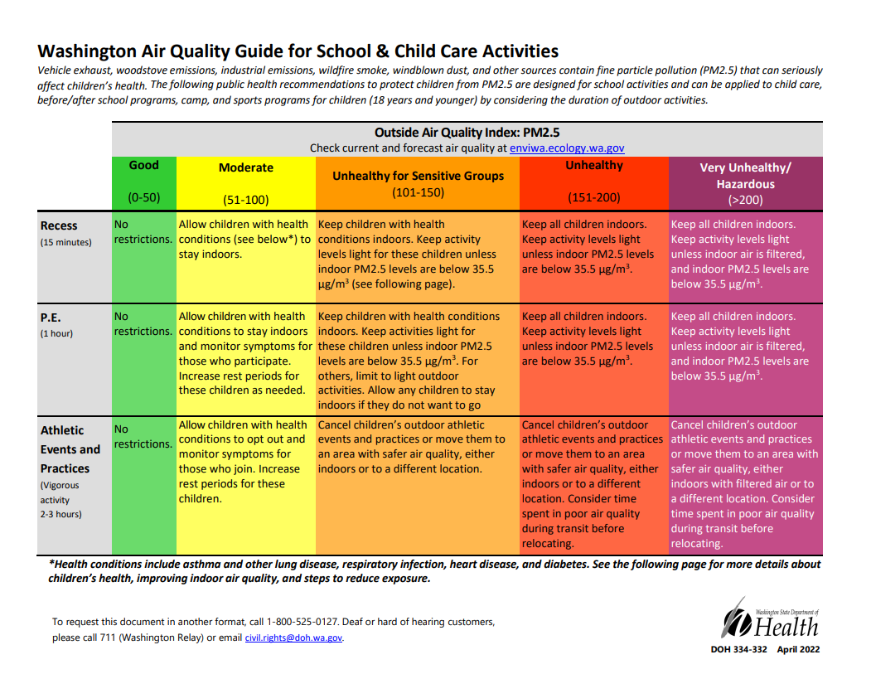

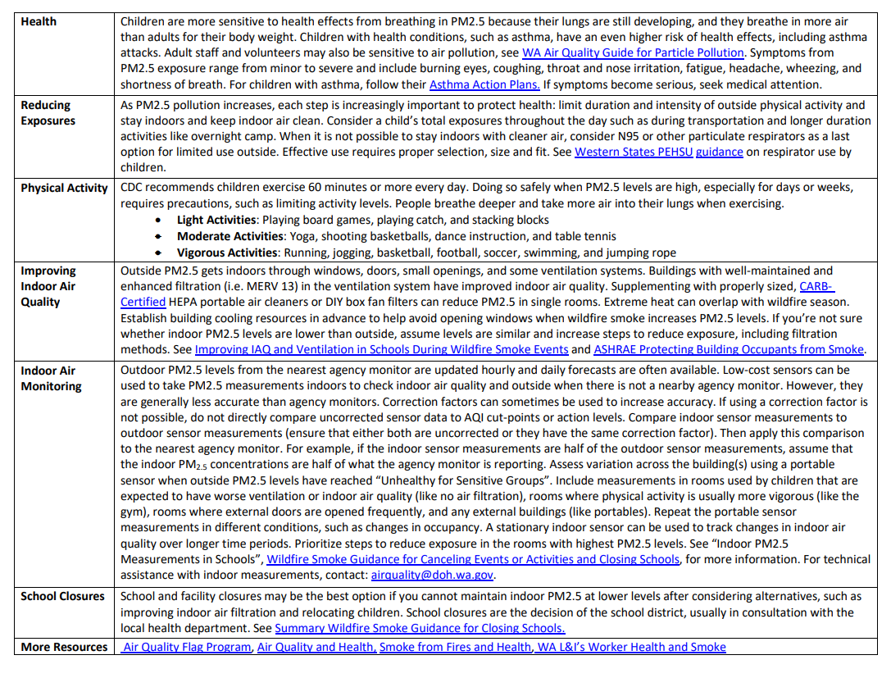

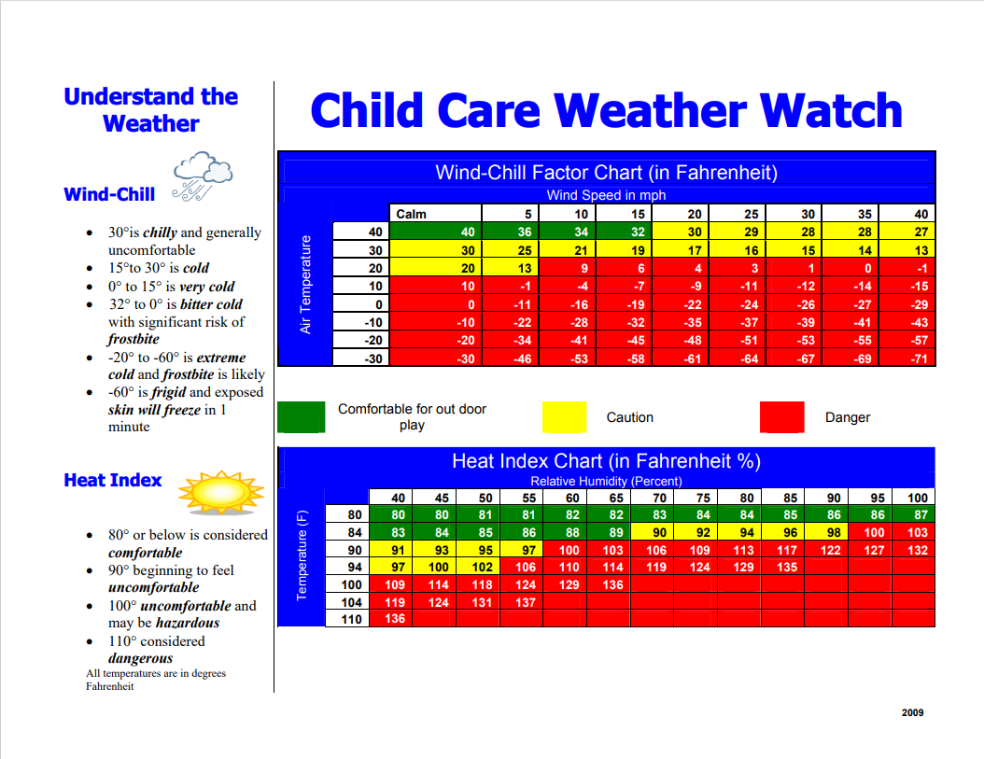

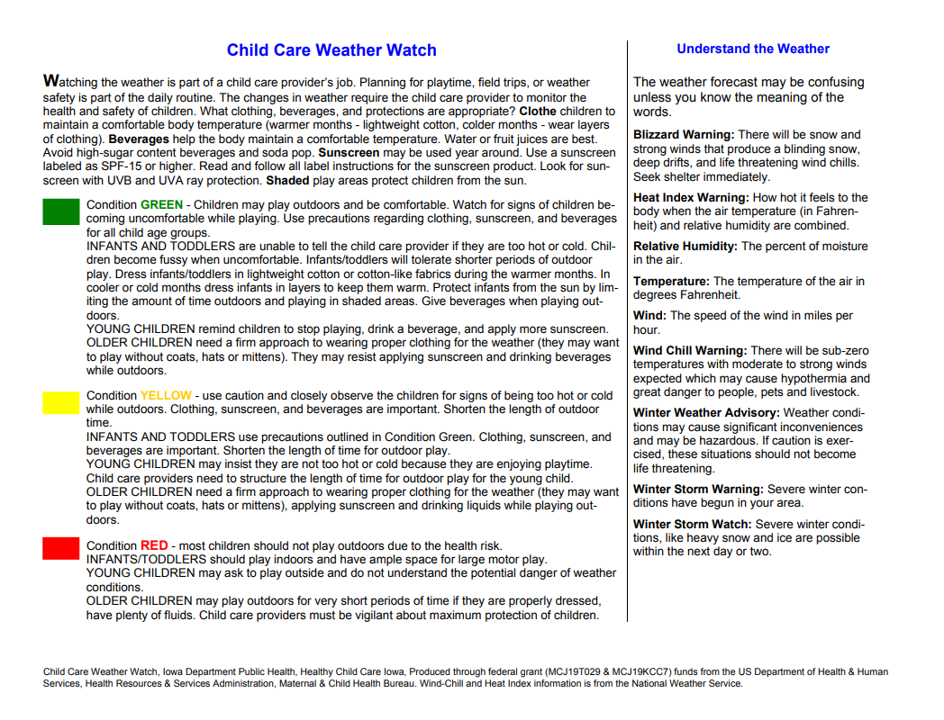

References

Bailey, B. A. (2015). Conscious Discipline: Building Resilient Classrooms. Loving Guidance Inc.
Community-Minded Enterprises. Community-Minded Enterprises. (n.d.). https://community-minded.org/
Foundational Quality Standards for Early Learning Programs, 110.300 WAC. (2023). Chapter 110-300 WAC:
Washington State Department of Children, Youth, and Families. (2023). 2023- 24 ECEAP Performance Standards. 2023-24 eceap performance standards (wa.gov)

My ECEAP Info

My classroom phone number is:
My first day of class is:
My classroom hours are: | 8:00 AM – 2:30 PM
My Teachers are:
My Lead Teacher is:
My Family Support Advocate is:
My site’s Manager is: | Kelsey Caynor
My site’s Director is: | Arrianne Maldonado

