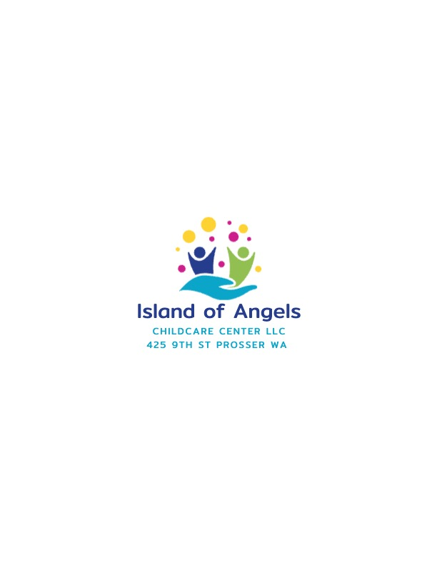
Center Phone: (509)786-0783 Director Cell Veronica Islas (509) 832-1380
Provider # 582128 DCYF contact (844) 626-8687
island_of_angels@yahoo.com
Child Care Registration Form |  |  | Date Child entered care |  | Date Child left care
Child’s name (Last, First, Middle) |  | Name used (Nickname) |  |  | Birthdate
Street address City Zip code
Child’s parent/guardian name | Circle the best number to contact you at when your child is in our care
Child’s parent/guardian name | Cell phone # |  |  | Home phone # | Alternative phone #
Street address City Zip code
Child’s parent/guardian name | Circle the best number to contact you at
Child’s parent/guardian name | Cell phone # |  |  | Home phone # |  | Alternative phone #
I give my permission for any of the following individuals to be contacted and my child may be released to any of them.
Parent/Guardian signature:__________________________________________ Date:_________________
In an emergency, if you are not able to contact me, contact the following individuals:
Name | Address | Phone numbers
Name:  Relationship:  Permission to pick up in emergency? |  | Work:  Cell:
Name:  Relationship:  Permission to pick up in emergency? |  | Work:  Cell:
Name:  Relationship:  Permission to pick up in emergency? |  | Work:  Cell:
Name:  Relationship:  Permission to pick up? |  | Work:  Cell:
These individuals also have permission to pick up my child:
Name (first and last) | Cell phone # | Home phone # |  |  | Alternative phone #
Who does NOT have permission to pick up your child? If applicable (A copy of supporting court document must be on file)
Name | Reason

Child’s health information
Child’s medical care provider or parent/guardian’s preferred medical facility for treatment  Name: Phone:  Street Address: |  |  |  | Child’s last physical exam, if available
Child’s dental care provider or parent/guardian’s preferred dental facility for treatment  Name: Phone:  Street Address: |  |  |  | Child’s last dental exam, if available
Health complications?  Yes or No? If yes, specify:  Regular medications?  Yes or no? If yes, specify: |  |  | Allergies, including drug reactions  Yes or no? If yes, specify:  Does your child have ADHD, ADD, Autism, Anxiety, Depression, ODD, OCD, ED, Schizophrenia or anything else we must be aware of?  Yes or No? If yes, specify:
Has your child attended other childcare facilities?  Yes or no? If yes, specify:  Reason for departure: |  |  | Does your child have any behavior issues that can be harmful to self, other children, or staff?  Yes or no? If yes, specify:

Consent to medical care and treatment of minor children
I give permission that my child, { }may be given first aid/ emergency treatment by the child care licensee and or qualified staff at:
Island of Angels Child Care Center LLC
425 9th St Prosser Wa
Parent/guardian signature | Date | Parent/guardian signature | Date
When I cannot be contacted, I authorize and consent to medical, surgical and hospital care, treatment, and procedures to be performed for my child by a licensed physician, health care provider, hospital or aid car attendant when deemed necessary or advisable by the physician or aid care attendant to safeguard by child’s health. I waive my right of informed consent to such treatment.
I also give my permission for my child to be transported by ambulance or aid car to an emergency center treatment.
I certify under penalty of perjury under the laws of the State of Washington that this information is true and correct.
Parent/ guardian signature | Date | Parent/guardian signature | Date

X X

X X
X X

X X
X X
X X

X X
X X
X X

X X
X X
X X

X X
X X
X X

Island of Angels Child Care Center LLC

Photo, video, or surveillance activity
I give permission for the licensee or the licensee’s staff to: yes no

Take photographs of my child for educational purposes, newsletter, ect. ……………….

Take videos of my child for educational purposes………………………………………..

Capture my child’s image on surveillance video used at this child care facility…………

I have reviewed the licensee’s written policies and have had the opportunity to discuss with the licensee the policies pertaining to the items listed on this permission form .

----------------------------------------------- --------------------------------------
Parent or guardian signature Date

----------------------------------------------- --------------------------------------
Parent or guardian signature Date

CHILD CARE AGREEMENT
Childs Name: First Middle Last

Parent or guardians name: First Middle Last

Days and times my child will receive care:
Check days of care | Sunday | Monday | Tuesday |  | Wednesday | Thursday | Friday | Saturday
Arrival time
Departure time
FEE: $ per: Hour  Day  Week  Month |  |  | Date payment due: 10th of each month
Source of payment:
Parent
Other (specify):
Overtime rate: $ 1 per: minute |  |  |  | Late fee: $ 50 per: month for every late payment
I agree to promptly notify the child care provider of any changes of the above information. I understand that I am fully responsible for the terms of this agreement as stipulated.
I have read, understand and agree to comply with the policy and procedures and information for parents given to me by:
Island of Angels Child Care LLC
Parent or guardian signature |  |  | Date |  | Parent or guardian signature |  |  | Date
I agree to provide child care services according to the above plan. I agree to promptly notify the parents or guardians of any changes to above information.

Island of Angels Child Care llc. 425 9th st Prosser WA 99350
Licensee signature: Veronica Islas |  |  |  |  |  |  | Date

Director cell Veronica Islas 509-832-1380
To apply call DCYF 844-626-8687
Provider ID #582128

