Creative Learning Center Montessori
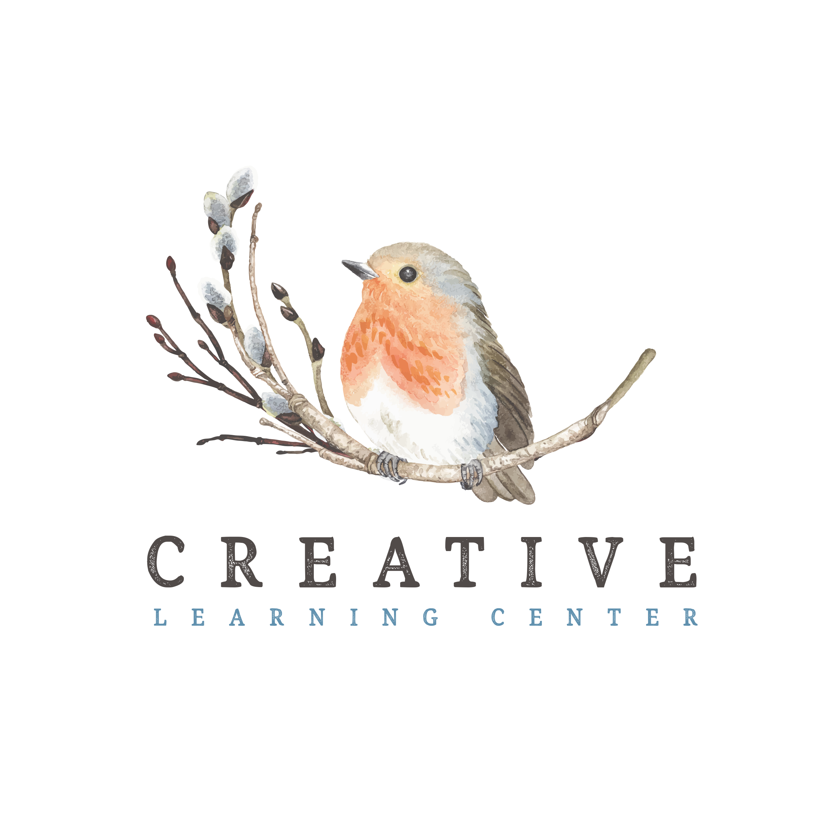
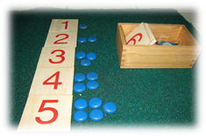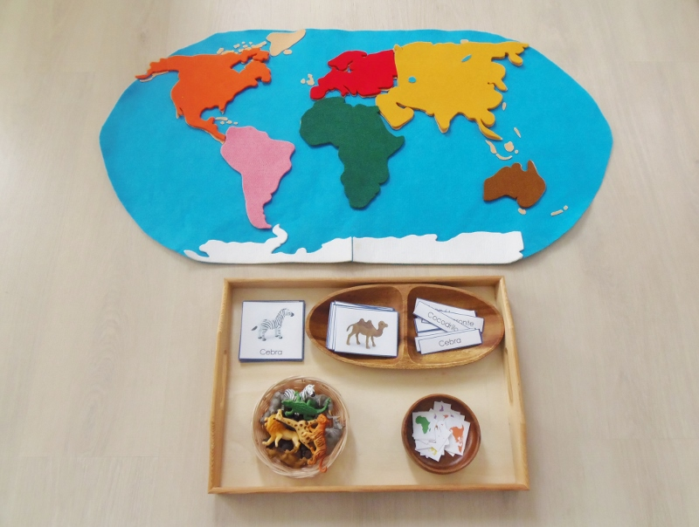

Policy Handbook

Introduction

Montessori recognizes the power of each child and the respect for their individual pattern of learning.

Our goal is to provide your children with a positive learning experience. We believe that a Montessori experience at a young age can help give children the building blocks needed for a successful introduction to the wonderful world of learning. Our team is dedicated to treat each child as an individual. Your child will be free to learn in an environment that is non-competitive, positive, encouraging and stimulating.

We strive to have your child view themselves as a lifelong learner. Learning is fun! Our philosophy is: It’s not about filling them with facts and figures but developing a love of learning and appreciation for the opportunities available to them.

In our Montessori environment, your child will develop a sense of independence. They will become self-sufficient, not having to rely on teachers for their every move. They will view themselves as capable, with an attitude of “I can do this!”

Creative Learning Center was established in 1993 by Marilyn Wellnitz. The school continues to flourish because of the trained, talented, and dedicated staff that come to school each day to love, care, and guide your children.

We are excited to give your children the wonderful experience of a Montessori education!
ADMISSION REQUIREMENTS AND ENROLLMENT PROCEDURES

INTRODUCTORY VISIT

It is recommended that each new child visit our classroom one time prior to enrollment. This will help reduce the anxiety associated with the first day of school.

ADMISSION FORMS

There are several forms required prior to your child’s attendance:

1. Child history.

2. Preschool registration form (with deposit).

3. Certificate of immunization status.

4. Home register form.

5. Consent for medical and/or surgical treatment.

6. Allergy forms for any child who requires an epi pen or special diet.

ITEMS FROM HOME

On or before the first day of school, we need each child to bring:

1. House slippers to be left at school.
2. Extra clothing.

On your child’s first day of school, please bring, in a zip-loc bag, a complete change of clothes. Every child should have an extra pair of socks, underwear, and clothes in a case of “spills”. Every item should be marked with iron-on tape, and a 3X5” card in the bag showing the child’s name.

Children’s clothing for school should be practical and washable. Play clothes for both boys and girls are suggested. When selecting slacks for children, check to see if the child can fasten and unfasten them him/herself. Overalls are not recommended.

We require parents to bring warm outer clothing for children to wear on the playground. It is necessary for each child to have a warm coat from October to May. Children go outside every day for 20-30 minutes, morning and afternoon. (Unless conditions are deemed unsafe) In the winter, children should wear long-sleeved shirts or sweaters to school. Classroom temperature is usually kept at about 70-72 degrees. Indoor slippers are required for all children.

Your child might enjoy owning a pair of leather shoes he/she may polish at school. Parents are asked to provide Velcro fastening shoes for children who are not yet tying. Please, no clogs!

Outdoor boots - The boots should be large enough that the child can put them on him/herself. Over boots should be at least two sizes larger than the shoes. Boots are recommended for our playground in the wet winter months.

A TYPICAL DAY

8:00-9:00 Kid’s Club
9:00-9:20 Circle time
9:20-11:00 Projects and Montessori lessons
9:20-11:00 Snacks
11:10-11:30 Outdoor play
11:30 - 12:15 Lunch
12:30-12:50 Circle time
12:50-2:30 Projects and Montessori lessons
12:50-2:30 Snacks
2:40-3:00 Outdoor play
3:00-5:30 Kid’s Club

FIRST DAYS OF SCHOOL

We have designed several ways to help your child enjoy the first day of school. Remember to give the school three pictures of your child prior to the beginning of school so that on the first day your child can see it on his/her personalized box, name card and lunch mat.

Should your child be hesitant to leave you, you may stay in the room with him/her for a recommended time of five minutes (if you feel it necessary). Almost always a child will become happy within minutes after a parent has left when he/she becomes occupied with the interesting activities in the school. If your child continues crying for more than fifteen minutes after you have left, a teacher will call to advise you.
DROP-OFF & PICK-UP TIMES

It is best for children to arrive and depart from school on time. Late arrivals disrupt other children’s focused activities. Picking up children late may as well be quite concerning for your child. Please call the school if you will be even a few minutes late, so we can let your child know.

SECURE ENTRY SIGN-IN/OUT

Parents will be provided with a security code to allow entrance into the classroom. To protect children in our care, do not give your code out to family, friends, even to older children in your family.

Only the people listed on the emergency/pick-up form will be allowed to pick-up your children. To alert the staff that someone other than the normal pick-up – please enter the information into the Brightwheel app or email and wait for confirmation. We will check for picture identification by any unfamiliar faces.

A parent or guardian must sign-in at arrival (Unless the child is dropped at receiving – in that case a teacher will sign them in) and sign-out for departure. This is a requirement for all licensed childcare facilities for the safety of each child. (In an emergency, the list will be used to verify which children are in our care)

LUNCH RECOMMENDATIONS AND REQUIREMENTS

**Nut Free Classrooms**

We strive to keep our lunch program as healthy and nutritious as possible. The list of “outlaw” food items are: candy (in any form), gum, Lunchables that include candy/ high sugar drinks, chocolate milk, sugar drinks (We only accept 100% fruit juice) granola bars that include any nut products. Milk will be provided; you may opt not to send a drink at all.

Parents may also opt into our hot lunch program through Farestart (Kids can enjoy either a hot lunch or sack lunch for an added fee)

To protect our nut allergy children - please check every item that goes into your child’s lunch. (If there is a questionable food item that does not have an ingredient list, please do not send it). Even though the children with nut allergies will not be eating lunch every day, it is still important to make sure there is not any peanut residue in the classroom.

State law requires the following food groups be included in each lunch:

- Protein – meat, cheese, eggs, peanut butter, etc. (one serving)
- Grain – roll, bread, pasta, tortilla, etc (one serving)
- Fruit – any (one serving if vegetable is included, or two servings)
- Vegetable – any (one serving if fruit is included, or two servings)
- Milk – will be provided.
CONFERENCES

Parent-teacher conferences are held during the fall and spring. A month before, an online link to sign up will be emailed. School is closed on these days (except for those children signed up for the full-time schedule) The purpose for each conference is to promote dialogue between the parents and teachers for the benefit of the child. Please do not bring your child to school during the fall conference. The spring conferences are student-led – the child is able to show you all they’ve been working on and their favorite activities. Although we schedule parent-teacher conferences in the fall and spring, special conferences may be arranged at any time. Please contact your child’s teacher to make an appointment.

CLASSROOM ACTIVITIES

The Montessori classroom is indeed a child’s world, geared to the size, the pace and interests of boys and girls between the ages of two and one half and six years old. It is designed to put the child at ease by giving him freedom in an environment prepared with attractive materials. These materials are arranged on low shelves within easy reach of even the smallest youngster.

The Montessori materials in the classroom can be divided into three main groups:

PRACTICAL LIFE

The beginning activities for two one half to four year old children. Using the child’s natural inclinations as a point of departure, Dr. Montessori structured several exercises for the classroom. These exercises satisfy the child’s need for meaningful activity. The practical life exercises use familiar objects - buttons, brushes, dishes, pitchers, water and many other things that the child recognizes from his home experience. For the young child there is something special about tasks that an adult considers ordinary - washing dishes, paring vegetables, and polishing shoes. They are exciting to the child because they allow him to imitate adults. The child prepares to learn by performing exercises that help him to gradually lengthen the time in which he can focus his attention on a specific activity.

SENSORIAL

The sensorial exercises are concerned with the development and refinement of the five senses, thereby sharpening the child’s intellect and control, preparing him for the more advanced exercises. The child learns by using both his hands and his mind. The sensorial materials in the Montessori classroom help the child to become aware of details by offering him, at first, strongly contrasted colors, such as red and blue, and then variously graded colors, such as many different shades of blue. Each of the sensorial materials isolates one defining quality such as color, weight, shape, texture, size, sound, smell, etc. The equipment emphasizes this one particular quality by elimination or minimizing other differences. Thus the sound boxes are all the same size, same shape, same color, and same texture; they differ only in the sounds that are made when the child shakes them.

ACADEMIC MATERIALS

Language Development - Reading and writing go hand in hand, and the early work with the Montessori sensorial materials prepares the child for the introduction to both. Through the sensorial exercises the child has learned the delicate handling of all the materials and has refined his movement of hand and fingers. These exercises are preparatory to handling the pencil. His sensitivity of touch has developed through the tactile exercises and the eye has been trained through sensorial exercises for developing eye-hand coordination. Through the use of the sandpaper letters the child learns to recognize the letters by sight and touch, as well as by hearing each letter spoken. He feels the letters with his fingers, tracing their outline in the same direction in which he will eventually write them. The alphabet sounds are learned individually, and then combined to form short words. The child sounds these words out phonetically, slowly at first, stressing each sound. Gradually he is able to blend the individual sounds together and say the whole word. Through repeated work with the materials, the child’s
reading and writing skills are developed and gradually new and more advanced lessons are introduced.

Mathematics - A child can learn basic concepts of mathematics in one of two ways. He can learn by using concrete materials during the years when he enjoys manipulating equipment; or he can learn by abstract methods when he is in the elementary grades. In a Montessori classroom a child will have access to mathematical equipment in his early years. He will easily and joyfully assimilate many facts and skills of arithmetic. On the other hand, these same facts and skills may require long hours of drudgery and drill if they are introduced to him later in abstract form.

In a Montessori environment, a child not only sees the symbol for 1, 10, 100 and 1,000; he can also hold each of the corresponding quantities in his hand. Later, by combining this equipment, separating it, sharing it, counting it, and comparing it, he can demonstrate to himself the basic operations of arithmetic. This activity gives him the satisfaction of learning by discovery rather than being told. Eventually, he develops an early enthusiasm for the world of numbers.

OTHER ACTIVITIES

HISTORY - Fossils, clocks, calendars, time lines, history of the earth, history of man, history of the U.S.A. (presidents, flags, clothing, food, etc.)

GEOGRAPHY - Physical and cultural geography. Puzzle maps, land and water formations, flag making, etc.

SCIENCE - Nature cards, botany, land, air and water activities, magnet experiments, etc.

CREATIVE ART - Painting, play dough, melt art, paper cutting, crayons, stencils, markers, collage, gluing, water colors, etc.

COOKING & MUSIC will also be included.

FREE ACCESS

Parents are welcome to visit our classroom at any time of the day.

DIAPERING PROCEDURE

One of the luxuries of a small class size is the ability to accept children who are still in diapers. We believe children should not be forced to be toilet trained so they can attend preschool. Every child has his or her individual agenda and sometimes it isn’t by the age of 2 1/2! We require disposable (preferably pull-ups) diapers. They are quicker, easier and create less mess. Our staff are meticulous about sanitation and cleanliness.

TOILET TRAINING

When you tell the teacher your child is ready, they will start assisting them in their toilet training. Please provide pull-ups during the toilet training period so that accidents will not be a problem or a negative experience for your child. If your child has any other requirements, please let your teacher know. We’ll want to continue the same routine you use at home to provide your child consistent training. Our goal is to provide a positive (non-stressful) toilet training experience for your child.

PET POLICY

List of Animals: Fish
Common health risks: Aquarium fish spread mycobacterial infections, which cause lung diseases, leprosy, and skin infections. Mini Hamsters: they can sometimes carry bacteria like Salmonella in their feces, and the virus that causes lymphocytic choriomeningitis.
Animals are located as follows: Fish – Island Room & Lake Room
No visiting animals are allowed
Child- Animal Interaction: Fish – children may watch the fish. They will not feed or touch the water.

PESTICIDE POLICY

In the case that outside yard pesticides will be used, parents will be notified in advance of the application at least 48 hours in advance.
GENERAL HEALTH CARE

- We use liquid antibacterial soap
- Your children will wash their hands upon arrival, before and after every trip to the bathroom, after playground time, and before each snack or meal.
- Equipment and toys will be disinfected daily.
- Carpets will be vacuumed daily, and vinyl floors will be mopped daily.
- We have an air purifier for each classroom with a true Hepa air filter that reduces up to 99.97 % of harmful germs, mold spores, viruses, and odors.

ILLNESSES

The following illnesses are not accepted in school:

- Fever of 100 degrees or higher.
- Vomiting two or more times within the past 24 hours.
- Diarrhea: Three or more episodes within the past 24 hours.
- A draining rash.
- Pink eye or a discharge from the eye.
- Fatigue or illness which prevents normal participation in daily activities.
- Green or yellow discharge from nose.

- If your child contracts a contagious illness (other than a cold), please inform me so that other parents may be advised.

- When recovering from a fever, a child should be kept home for one full day after his fever subsides.

If a child should become ill during the day, you will be notified immediately and will be expected to pick up your child as soon as possible. In such event, your child will be separated from the
other children until you arrive. (We will administer TLC and a
warm blanket)
- Please call the school if your child will not be coming due to illness. If you are unsure if your child should come or not, please call.
- Our staff will report immediately an occurrence of food poisoning or reportable communicable disease, as required by the state board of health to the local public health department and to the licensor, by telephone.

MEDICAL EMERGENCIES

- All teachers have First Aid and Child CPR training.
- Minor cuts, bruises, scrapes will be treated. Parents will be notified through our BrightWheel app and also upon arrival.
- In an emergency situation, the staff will call 911. Staff will manage the situation until other trained medical help arrive. You will be notified immediately.
- If injury/incident results in casting, stitches, or hospitalization, we are required to notify the Dept. of Child, Youth and Families. licenser and to submit an “Injury/Incident Report”, you will also be supplied with a copy.
- Parents/guardians are expected to assume responsibility for any resultant expense not covered by school insurance and you are responsible for the filing of all insurance claims.

INJURY PREVENTION

We have taken the following precautions to safe proof our classroom:

- Electrical outlets are tamper resistant.
- All toxic or medicinal substances are safely stored in locked overhead cabinets.
- Fire alarm system.
- First aid kit and fire extinguisher in each classroom.
- Fully fenced outdoor play area.

MEDICATION POLICIES

- All medications shall be administered only on the written approval of a parent or guardian.
- Prescription medications shall be administered only as directed on the label or as otherwise authorized by a physician.
- Medications must be stored in their original container. The container must have the patient’s name, instructions and date of expiration.
- A doctor’s permission is not required for non-prescription drugs.
- A detailed record will be kept of all medicines given.

FIRE & EARTHQUAKE/DISASTER DRILLS

Fire & earthquake/disaster drills are conducted monthly at random times. For the fire drills: The children will be told which evacuation route to use. Able children will be taught how to crawl on their knees when exiting to avoid smoke inhalation and how to identify danger signs (e.g.: hot doors, smoke, etc.) Earthquake/disaster drills: children will practice going under the tables “duckies under the table!” They will be instructed to stay until the teacher gives the okay. Fire & Earthquake/disaster drills and smoke detector tests are recorded on the bulletin board.

CAUSES FOR TERMINATION

- Behavior problems that cannot be worked out after a fair amount of time. We reserve the right to terminate care immediately if the
behavior problems are severe or interfere with the normal
activities of the children in the school. Any unused tuition will be returned upon dismissal.
- Consistent late pick up of your child. Deposit will not be returned
- Not paying your child’s tuition bill. Deposit will not be returned.
- Unresolved disagreements with parents over policies. Deposit returned at the director’s discretion.

VACATIONS/HOLIDAYS

Creative Learning Center is closed on all vacation and holidays, which coincides with the Mercer Island School District. A calendar will be provided by June before the upcoming school year

Tuition is paid on a monthly basis and is not prorated for sick days, personal vacations, holidays, or snow days/emergency closures.

BAD WEATHER/EMERGENCY CLOSING/COVID

When the Mercer Island School District closes due to bad weather, Creative Learning Center will also close in most cases. (If there are any changes, parents will be notified). Parents will be notified by email and the Brightwheel app. Parents can also listen to the radio and television for confirmation of closing. Class will only be canceled to assure the safety of the children. (No refunds will be made due to any emergency closure – which includes pandemic or quarantine closures)

BIRTHDAYS

Children’s birthdays may be celebrated on the actual birth date or the closest school day to it. We celebrate by having a special circle (parents are invited) and the birthday child prepares a healthy snack to share with their friends.

In order to foster a spirit of giving away at birthdays, it is suggested that the birthday child bring a gift for the classroom to the school on that day. (A book, rock or artifacts are some suggestions.)

FIELD TRIPS

Family field trips will be taken in the fall and spring. We often ask parents of special places they have visited in the area - if you have any unusual or interesting ideas, please let us know!

SNACKS

Parents will provide snacks on a rotating basis. You will receive complete instructions before your child’s assigned week. We often enjoy matching the snack to the theme we have each week. (E.g.: Communication - edible envelopes, Pets - Dogs in a Blanket, etc.) The snacks will be taken from two food groups each day. The snacks will be nutritious and at least partially made by the child him/herself with help from the teachers. Sugar will be limited in these snacks.

CHILD ABUSE REPORTING

As required by law, our staff will report immediately any instance when we have reason to suspect the occurrence of any physical, sexual, or emotional child abuse or child neglect, child endangerment, or child exploitation.

RELIGIOUS ACTIVITIES

Creative Learning Center observes traditional Christian and Jewish holidays such as Christmas/Hanukkah and Easter/Passover. At holiday times we will normally have decorations, music, art projects and cooking in observance.

RULES

- Parents (or other approved persons) are required to sign their child/children in and out at time of drop off and pick up.
- Please do not send your child to school gum, hard candy or money.
- It is important to have you child in school on time.
- There will be positively, absolutely no biting, hitting, swearing,
etc.!

WITHDRAWAL

A sixty-day written notice of student withdrawal from class is required. If no notice is given, parents are still responsible for the following two month’s tuition.

DISCRIMINATION POLICY

Our school will provide the opportunity for all children to learn free from the limitation of race, color, religion, and national origin.

It is our belief that ethnic, racial, religious, and economic diversity are essential for education and growth of the whole child. In this environment, children are able to gain a deeper understanding and acceptance of all mankind.

CREATIVE LEARNING CENTERS’ APPROACH TO DISCIPLINE

The Montessori philosophy provides a thorough approach to children and life. The most important feature is simple: Children are inherently good and it is our responsibility as teachers and parents to lead them into happy fulfilling lives. Through respect, trust freedom of choice, and guidance, good will is predominant.

APPROACH TO DISCIPLINE (CONTINUED)

Therefore, discipline from the teacher becomes the exception rather than the rule. The classroom management techniques outlined below illustrate how every child can achieve the following characteristics:

- Joy of learning
- Learning through discovery
- Independence
- Self-discipline
- Ability to choose
- Love of order
- Self -confidence
- Enjoyment of quiet
- Self-motivation
- A wonder and curiosity about the world around them
- A respect for people and the environment

FREEDOM

- Freedom to choose the work he/she wishes will mean a better quality and greater quantity of learning in the long run. Rather than the teacher choosing what the child will learn at a particular time, it is the teacher’s job to observe the child’s sensitive periods, identify what he/she needs, and provide the child with a means to meet these needs. The child will then be capable of achieving self-discipline.

- Freedom to solve their own problems builds an inner desire to get along with others, to share, and to find solutions which will make everyone happy. This does not come instantaneously, but given time, the child’s solutions will come naturally and carry infinitely more weight. At first they may come to you for assistance since they are used to “telling on” each other and having an adult solve the problem. When someone comes to the teacher crying, the teacher may suggest: “You may use words to tell her how you feel.” The teacher can also restate the problem and ask the child for solutions. If the child is stuck, solutions can be suggested and then the child decides if they’d like to use different one.

POSITIVE ATTITUDE

- Have fun and enjoy the children and yourself.
- Children sense your frame of mind. The teacher’s happiness will influence the child’s happiness.
- Approach problems with the idea that solutions can be found that will make everyone satisfied.

DRAW THE CHILDREN INTO LEARNING

- Learning is fun and exciting. You will often hear a teacher pause and exclaim “Aren’t we lucky we get to learn new things!” We are lucky!!
- Use many variations in every aspect of the classroom. Do not let the class get dull.
- Always combine an aspect of the unknown with an aspect of the known. This will allow the children to move forward and stay interested with a quick transition.

MODELING AND STATING LIMITS

- All work pieces are demonstrated first before the children may use them.
- Do not interrupt a child’s work unless he/she is having major difficulties or is doing something with major ramifications. Usually the teacher will just need to give another demonstration before the child does the work again emphasizing the part where he/she is having problems.
- If you expect a child not to do something, do not do it yourself.

Here are some verbal and nonverbal cues we use to instill the classroom limits as we are doing a task ourselves:

- Talk quietly
- Walk slowly
- Be absorbed in the work you are demonstrating
- Carry equipment carefully with two hands
- Do the demonstrations slowly and carefully
- “Our rug is our special work area, no one may touch it without our permission”
- “We walk around our rugs”
- If you must remind them of a limit, always use a positive phrase rather than a negative one (e.g.: “You may walk in school” or “We use quiet voices inside”)

DO NOT DO FOR THE CHILDREN WHAT THEY CAN DO FOR THEMSELVES

- Allow the children to fail as long as the task is not impossible for them. They will eventually succeed. We learn through our failures. It is the confidence to keep trying that is important.
- It is the children’s flow that is followed, not schedules. A teacher will not interrupt a child’s work to meet a predetermined schedule.
- Teachers will not put their hands on a child’s work unless that child is abusing equipment or another person.

ACTIVE LISTENING & I-STATEMENTS

- “Active listening” involves empathizing with the child when they own a problem and allows them to solve it themselves.
- “I-statement” involves showing others exactly how you feel by stating your problem concisely and without anger. This allows the listener to be empathetic and to want to help you. After all, it is your problem and what is important is finding a solution - not placing blame.
- Many of the principals and theories used in the classroom are taken from the books “Parent Effectiveness Training” and “Teacher Effectiveness Training” written by Dr. Thomas Gordon.

POSITIVE DISCIPLINE

- “Positive Discipline” is a method developed by Jane Nelson and published in her book Positive Discipline.
- This method begins by introducing the children to simple logical consequences (e.g.: “If we go out in the rain without a coat, what happens?” asks the teacher, “We get wet” respond the children).
- Logical consequences are then introduced for negative actions occurring in the class.
- Later, when the children are very familiar with the concept of logical consequences, they may begin determining their own logical consequences for their actions. The children then become responsible for their own actions and develop self-discipline.

TIME OUTS

If a child needs to be separated from the class, we will often refer to it as a “rest” or “thinking time”. They will be instructed to sit quietly until they are ready to work in a positive way. The child decides when he/she is ready to return and work again. (Yes, this is very effective!)

In case of serious misbehavior (repeated biting, physical injury to others, etc) The teacher will remove the child from the school and contact the parent to have the child picked up.

CORPORAL PUNISHMENT

Spanking or any other form of corporal punishment will not be used.

RECURRING PROBLEMS

- Find out why the problem is occurring and try to stop it through prevention. Change something about the sequence of events that led up to the problem the last time: The environment, the wording you use, the seating positions around a table, or even the daily routine may be modified.

Expulsion Policy
At our facility we will work with each individual child promoting consistent care and maximize opportunities for child development and learning. When a Child exhibits behavior that presents serious safety concern for the child or others and the program is not able to reduce or eliminate the safety concern through reasonable modifications the child’s care will be terminated. Some examples are on-going biting beyond the toddler age, throwing objects at others, hitting with objects, leaving the facility and other behaviors.
Prior to expulsion of services due to child’s behavior we will provide the following supports:
1. We will have a parent or guardian meeting weekly or more frequently as needed.
2. We will review the expulsion policy with the parents or guardians.
3. We will record the incidents that led up to the expulsion, include the date, time, staff involved and details of the incidents
4. We will give the parents or guardians a copy of the steps that were taken to avoid expulsion
5. We will give the parents or guardians a description of the environmental change, staff change and other reasonable modifications that were made.
6. We will have a behavior plan developed with the parents. A copy of this plan will be given to all teachers, support staff and parents or guardians.
7. We will give the parents or guardians referrals to community-based programs/settings
The Department will be notified of the expulsion.

Restraint Policy
Physical restraint must only be used if a child's safety or the safety of others is threatened and must be: (a) Limited to holding a child as gently as possible to accomplish restraint; (b) Limited to the minimum amount of time necessary to control the situation; and (c) Developmentally appropriate.

RECOMMENDED READING

MONTESSORI IN THE HOME........Hainstock, Elizabeth

MONTESSORI, A MODERN APPROACH............Lillard, Paula Pole

POSITIVE DISCIPLINE............................................Nelson, Jane

PARENT EFFECTIVENESS TRAINING ...........Dr. Gordon, Thomas

THE ABSORBENT MIND, THE MONTESSORI METHOD,
THE CHILD IN THE FAMILY, DISCOVERY OF THE CHILD, SECRET OF CHILDHOOD, DR. MONTESSORI’S OWN HANDBOOK...........................................................Montessori, Maria

