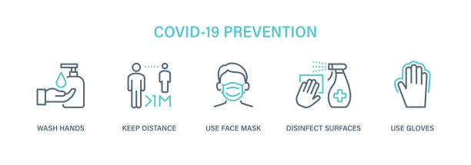
Our families are our priority, especially in these difficult times. We are committed to maintaining a safe, healthy environment.​​This page was created to share the steps we’re taking to keep the children, their families, and the us safe in our daycare. Together we can get through this.
How we’re keeping Toot-Toot Daycare and your family safe:
​
Drop off & pick up procedures:
Our new routines for drop-off and pick-up are designed to ensure everyone in our daycare stays healthy and safe. Only one family at a time will be permitted inside the foyer, where we will conduct a quick health screening to ensure your child does not have a fever above 100.4 degrees Fahrenheit or other flu-like symptoms. Then, we will take your child
to and from the daycare area. For pick-up, we will bring your child to the foyer. Please be mindful of keeping a six-foot distance from others during drop-off and pick-up.
​
Social Distancing:
We will practice social distancing in the daycare throughout the day. Your children will remain in the specific areas. All special events and visitors will be postponed until further notice.
​
Keeping areas clean:
We have implemented an even more rigorous cleaning routine, and all high-touch surfaces and objects will be sanitized regularly throughout the day. These include, but are not limited to, all learning materials, playground structures, light switches, and door handles.

Food prep procedures:
Teachers will continue to wear gloves while helping children with snack time and lunch. We will discontinue family-style servings at snack time. Instead, we will serve children individually.
​
Face Covers:
We have provided all staff and parents with guidance and best practices about wearing face coverings at daycare. Along with our guidance, daycares must follow local health and state guidelines to ensure they’re compliant with health and safety orders.

What to do if your child is sick or a family member has been diagnosed with Covid-19:
For the safety of children, families, and staff at Toot-Toot Daycare, anyone who is ill must stay home. If you or a loved one has been diagnosed with COVID-19, immediately alert Diane the daycare’s owner and stay home. In addition, please follow the CDC’s recommendations if you’re unwell or if you have been diagnosed with COVID-19.

Covid-19 Resources links to helpful information
https://coronavirus.health.ny.gov/home
https://ocfs.ny.gov/main/news/COVID-19/#t1-Guidance-Documents

